**Studiu asupra imbunatatirii unui sistem folosind procese automate de testare si monitorizare continua a performantei**

**Studiul metodologiilor si solutiilor pentru imbunatatirea performantelor unei aplicatii software**

**JMeter Experiments**

The JMeter tool was used to perform a series of measurements and evaluate different metrics for each use case scenario (application flow) that might be accomplished by a user of the ScrumTaskboard web application. In addition to a wide variety of monitoring utilities that are provided by the JMeter tool, its main functionality is given by the virtual simulation of an established number of concurrent users. Therefore, several tests were conducted by suddenly changing the number of concurrent users (threads) of the web application. The results gathered from analyzing these tests’ outcome are as follows:

* For the **Login User** test case:
* The application responds successfully to 100 concurrent users (threads). This result is recorded in the images listed below which were obtained from different measurements:

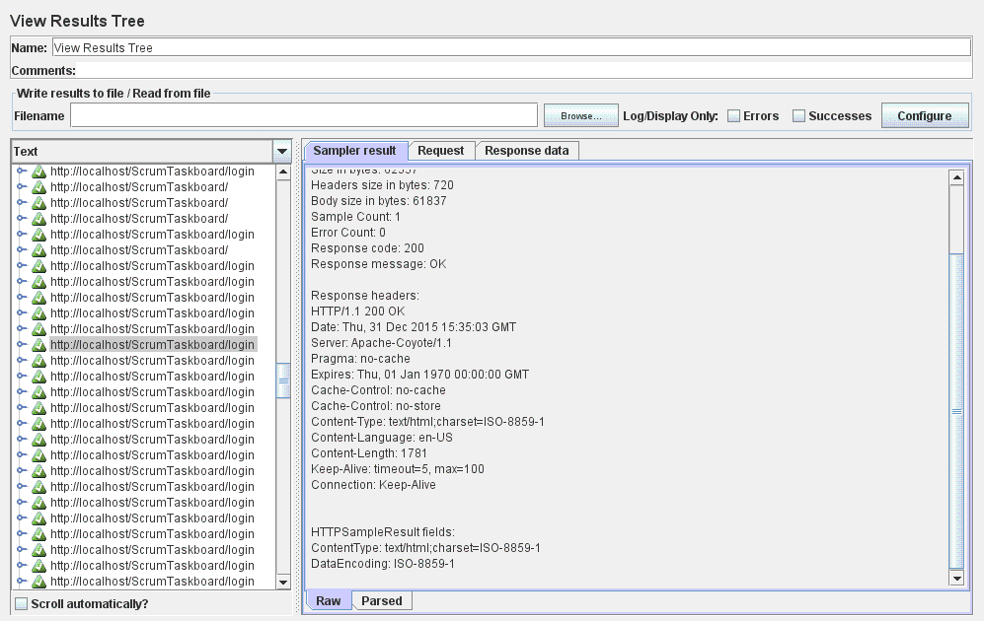

Figure 1: View Results Tree

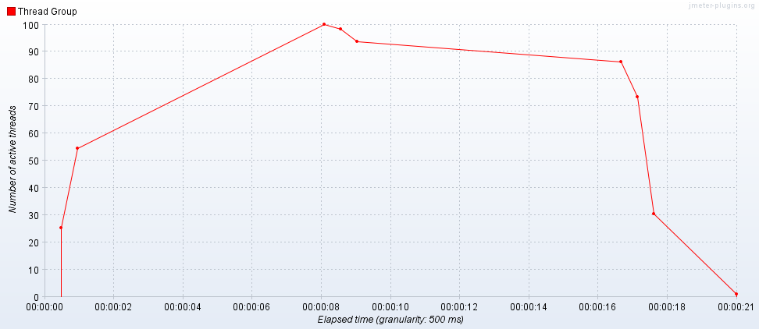

Figure 2: Active Threads Over Time

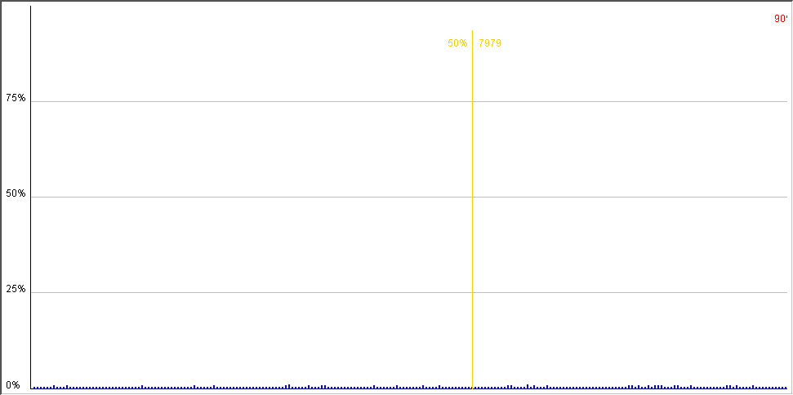

Figure 3: Distribution graph-alpha

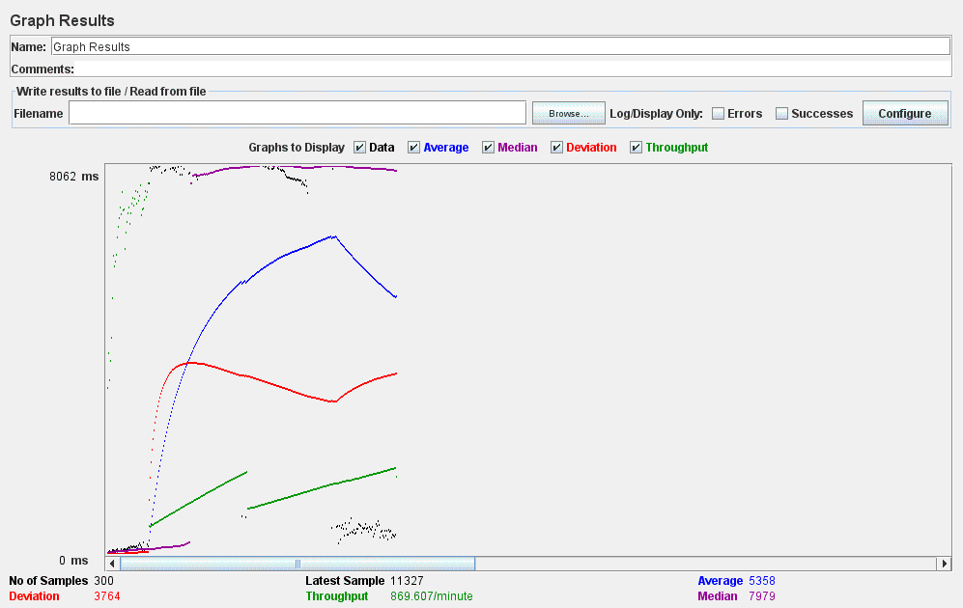

Figure 4: Graph Results

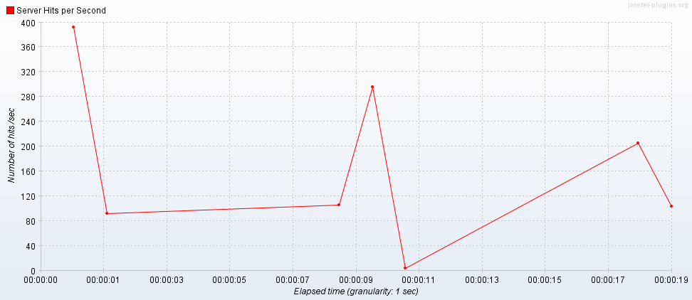

Figure 5: Hits per Second

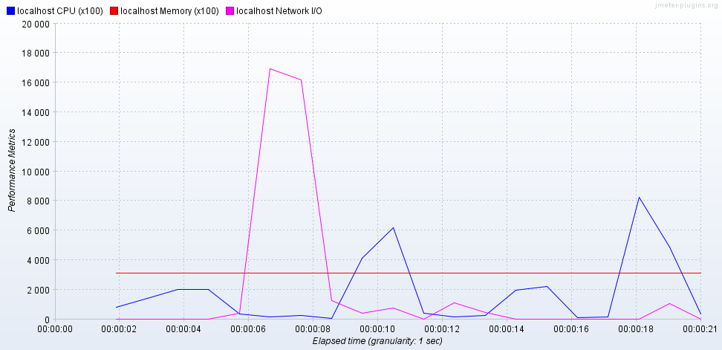

Figure 6: PerfMon Metrics Collector

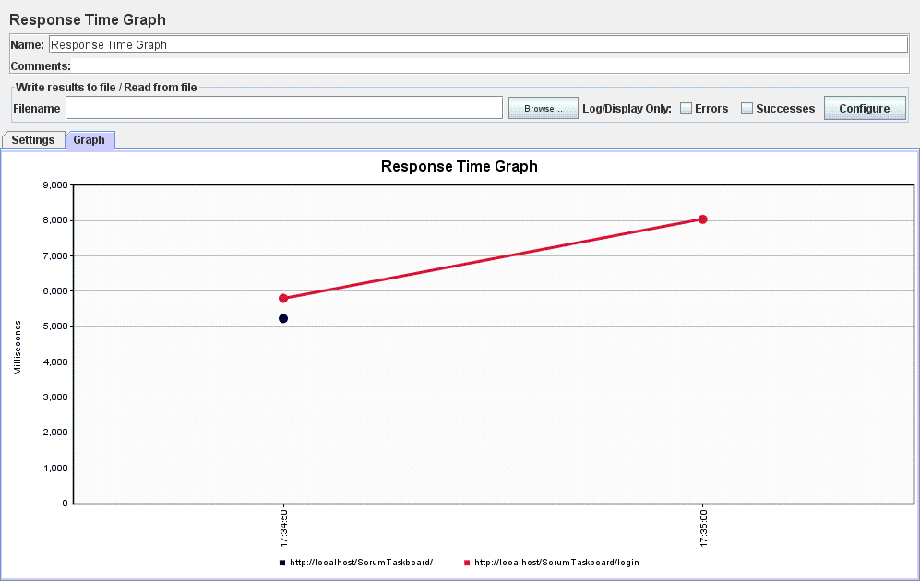

Figure 7: Response Time Graph

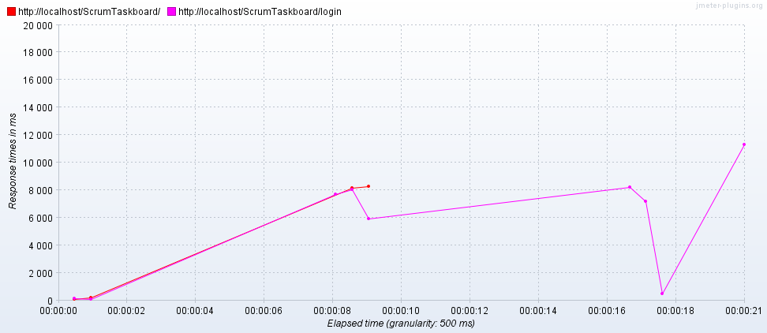

Figure 8: Response Times Over Time

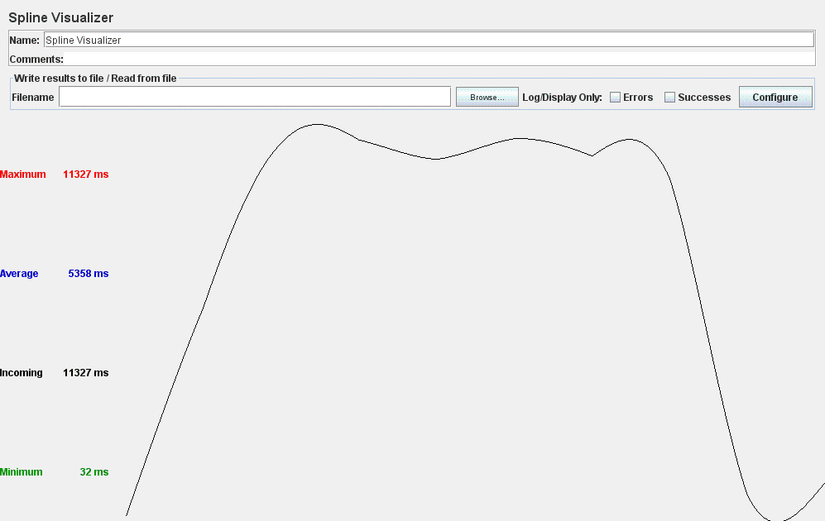

Figure 9: Spline Visualizer

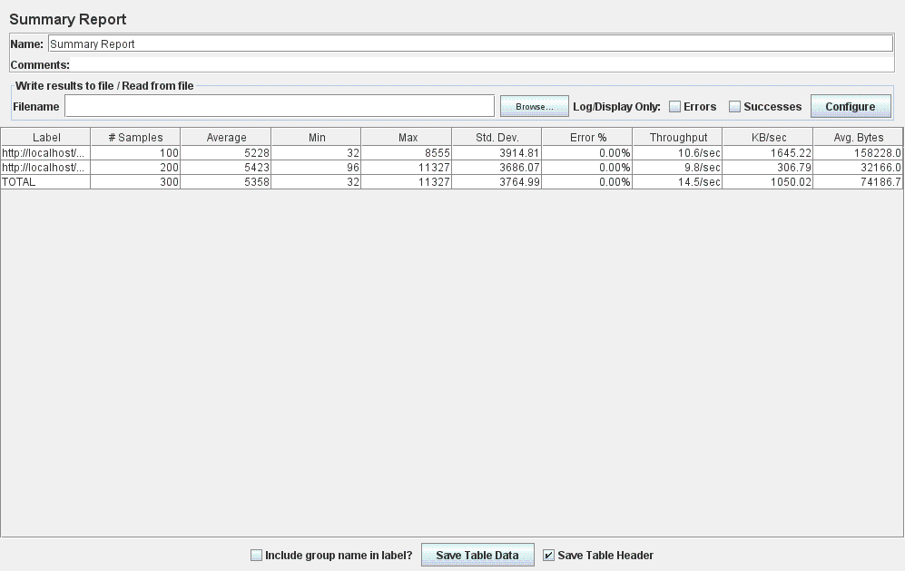

Figure 10: Summary Report

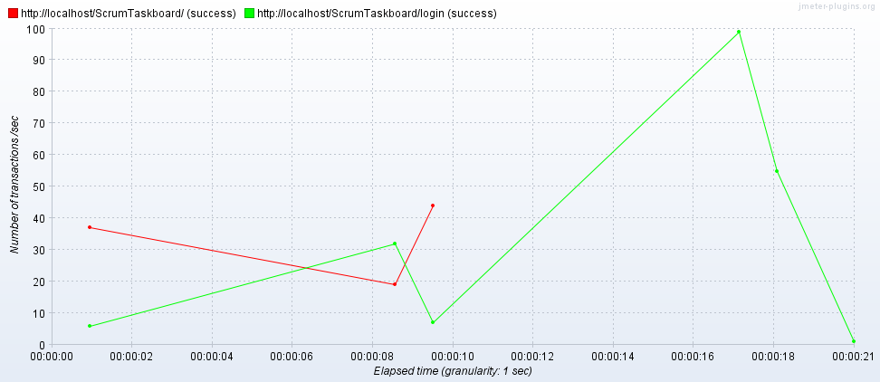

Figure 11: Transactions per Second

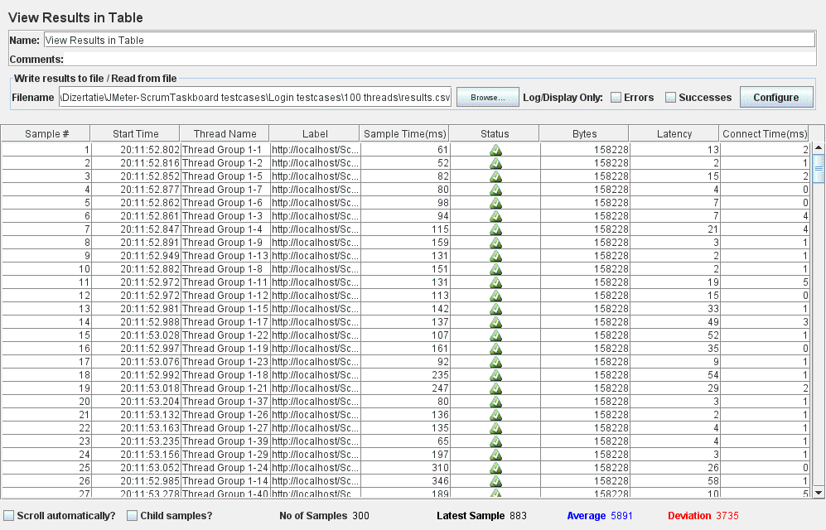

Figure 12: View Results in Table

* The application responds is unable to successfully handle a number of 300 concurrent users (threads) attempting to log in. Figure 13 listed below shows several requests for which the application responded with error. Additional information might be gathered by analyzing the results obtained from different measurements:

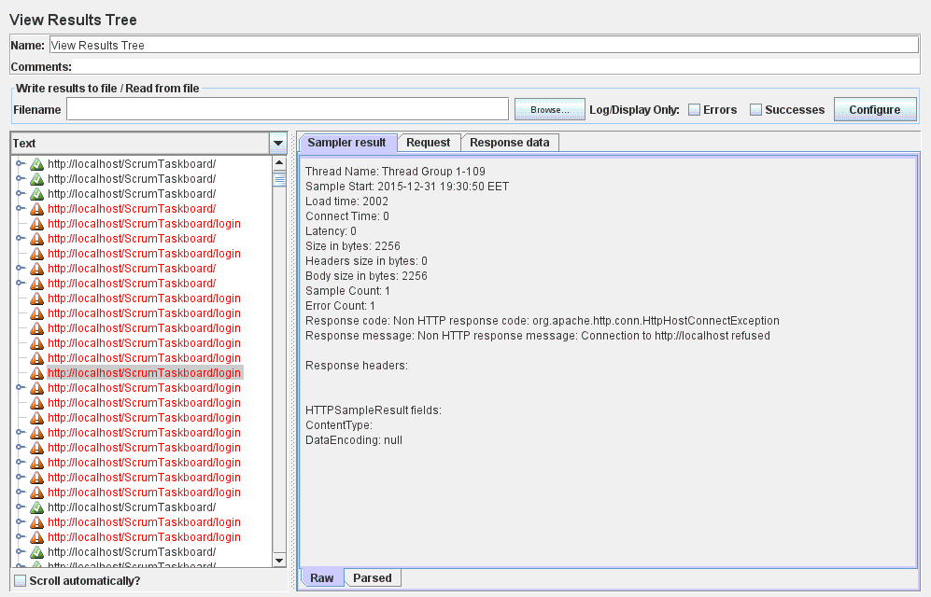

Figure 13: View Results Tree

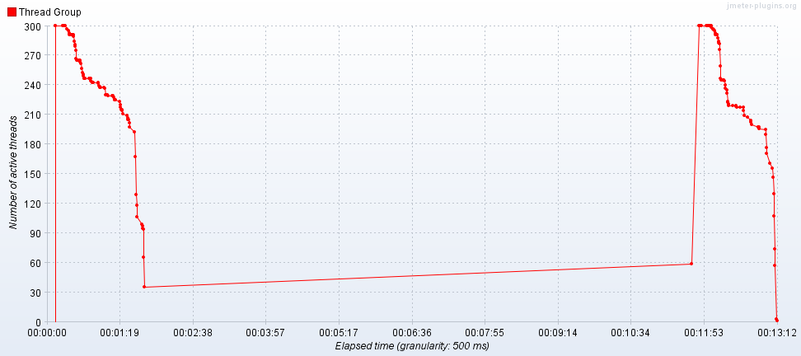

Figure 14: Active Threads Over Time

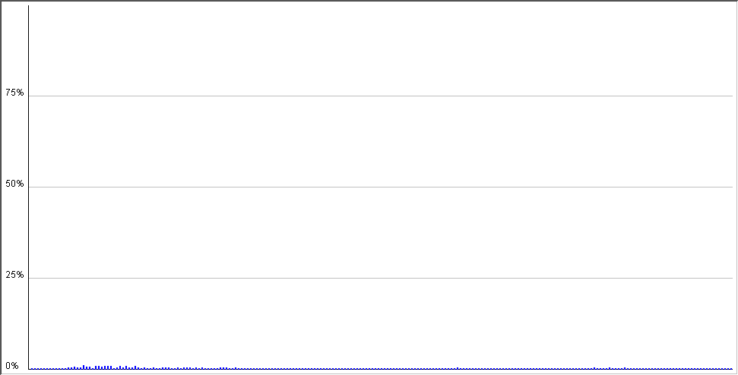

Figure 15: Distribution Graph (alpha)

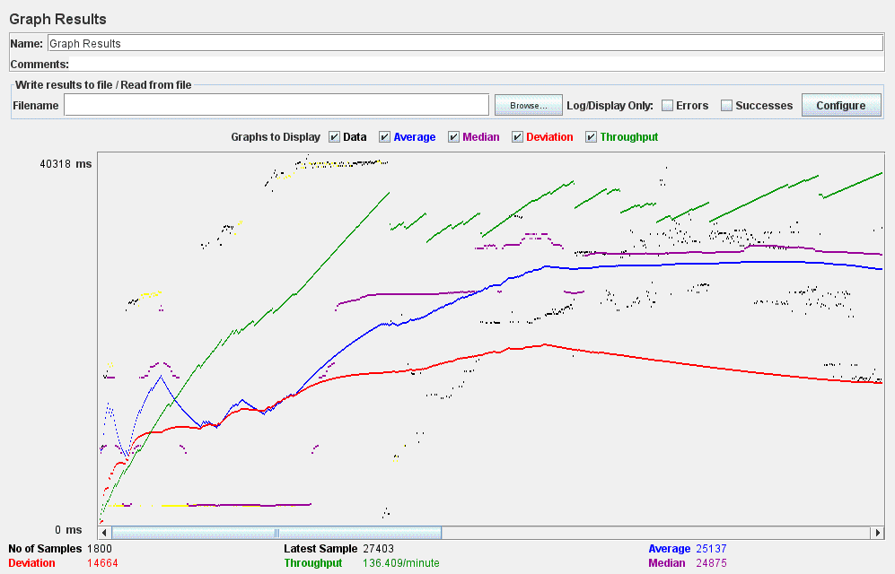

Figure 16: Graph Results

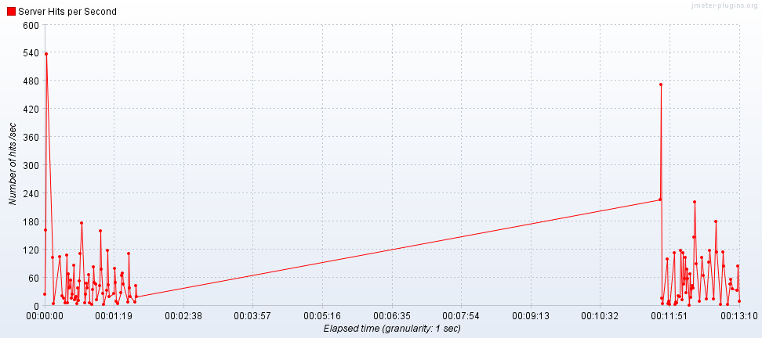

Figure 17: Hits per Second

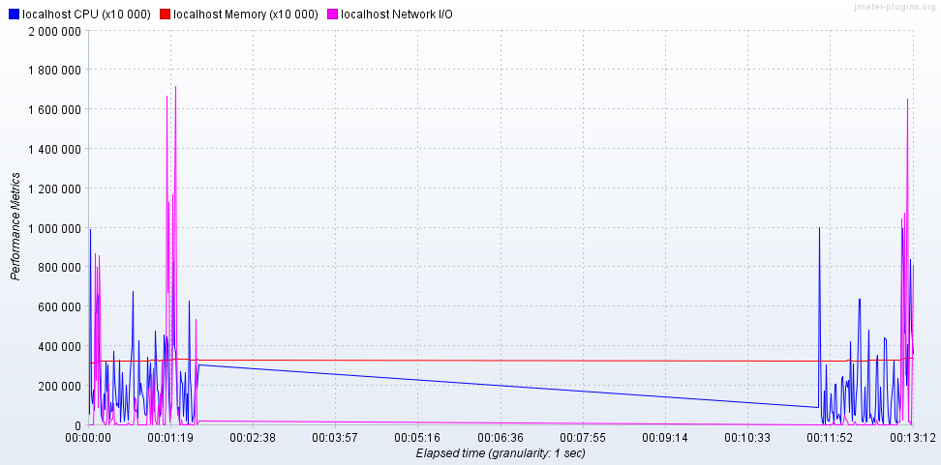

Figure 18: PerfMon Metrics Collector

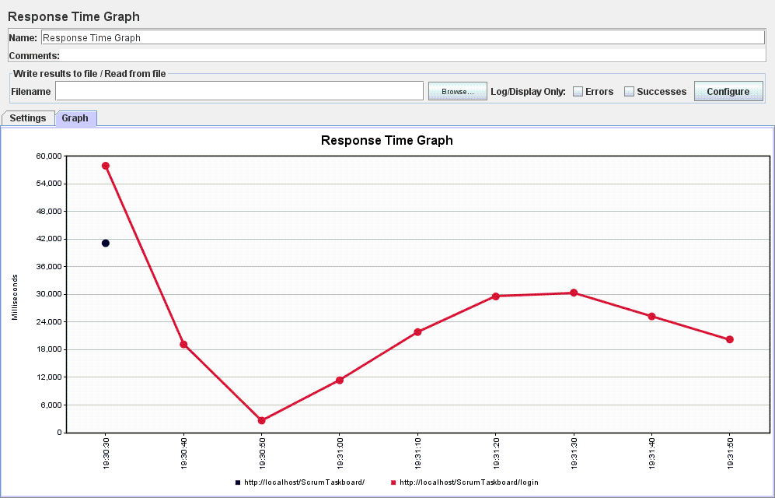

Figure 19: Response Time Graph

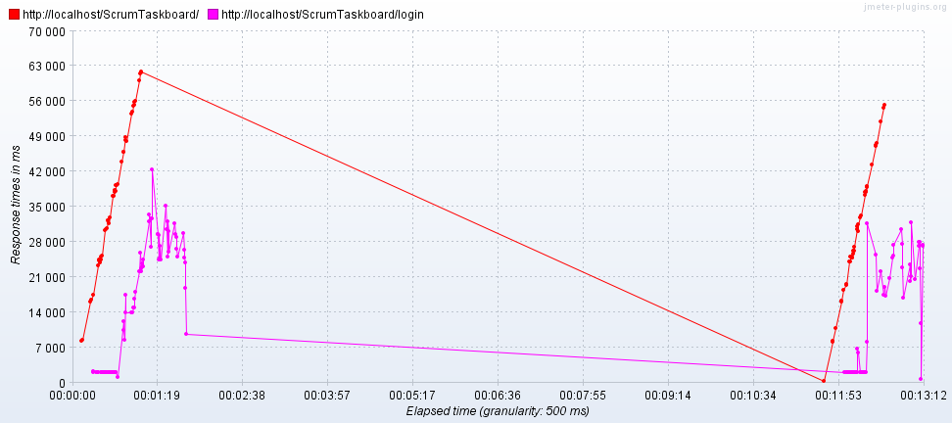

Figure 20: Response Times Over Time

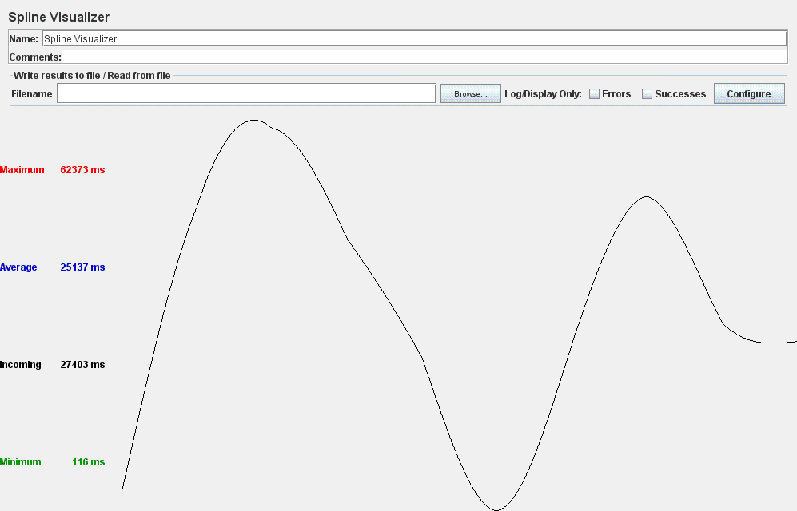

Figure 21: Spline Visualizer

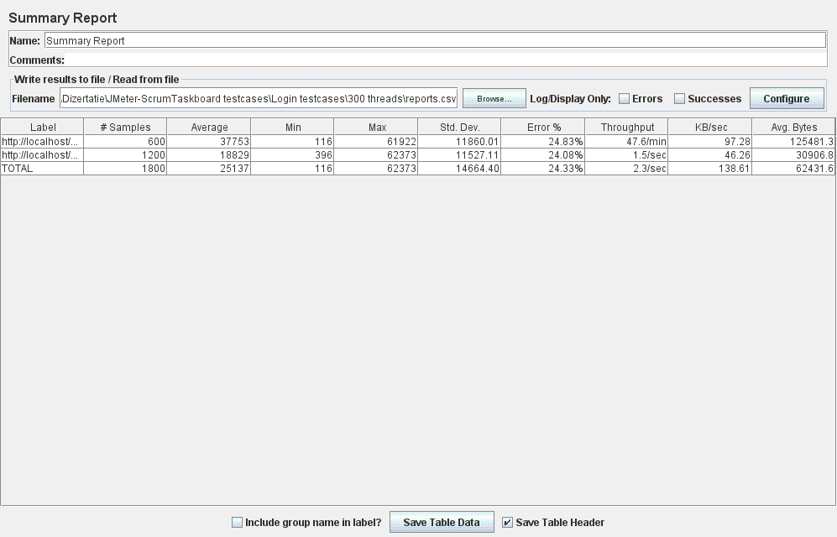

Figure 22: Summary Report

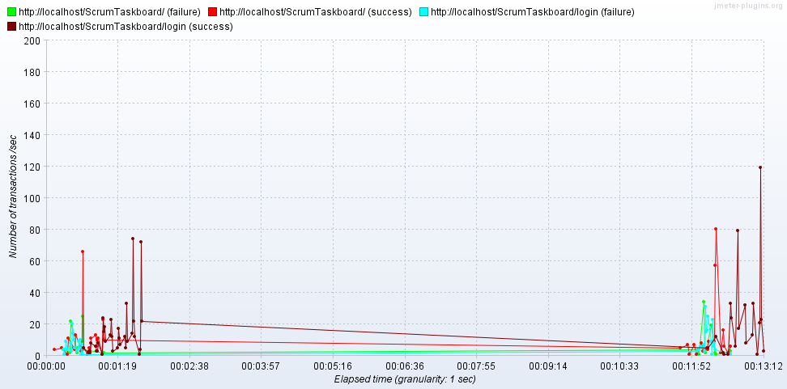

Figure 23: Transactions per Second

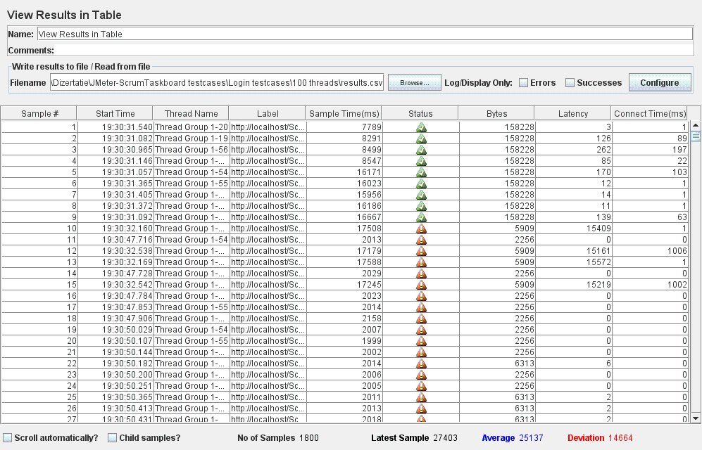

Figure 24: View Results in Table

* Even worst results are obtained when a number of 500 users (threads) try to simultaneously log in to the ScrumTaskboard web application. This outcome is denoted by the pictures obtained by performing a series of metrics on this scenario:

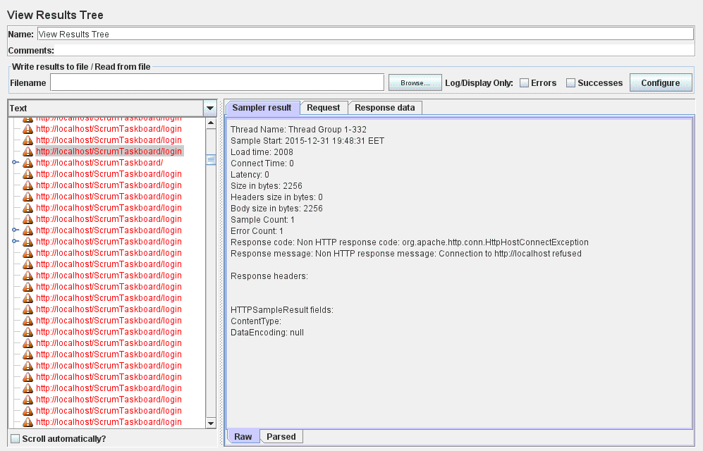

Figure 25: View Results Tree

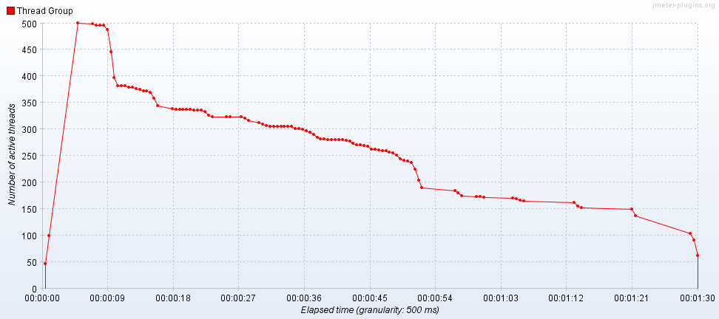

Figure 26: Active Threads Over Time

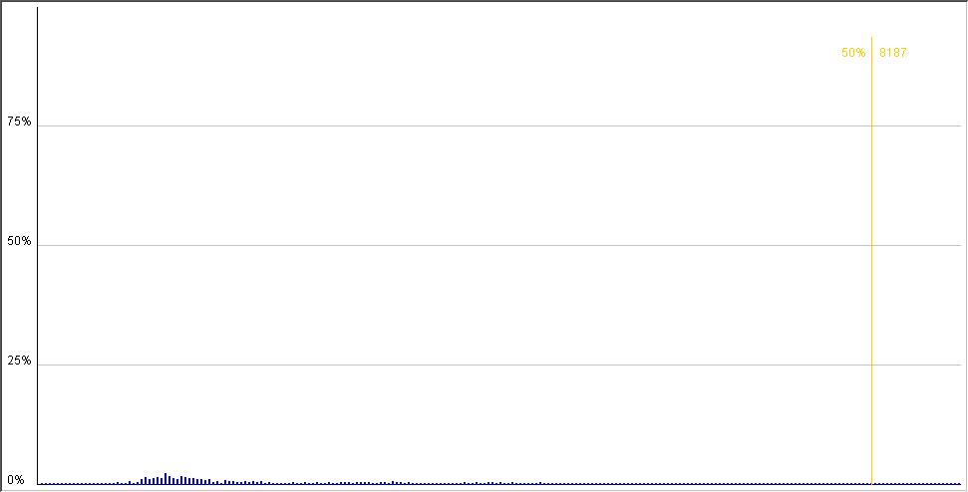

Figure 27: Distribution Graph (alpha)

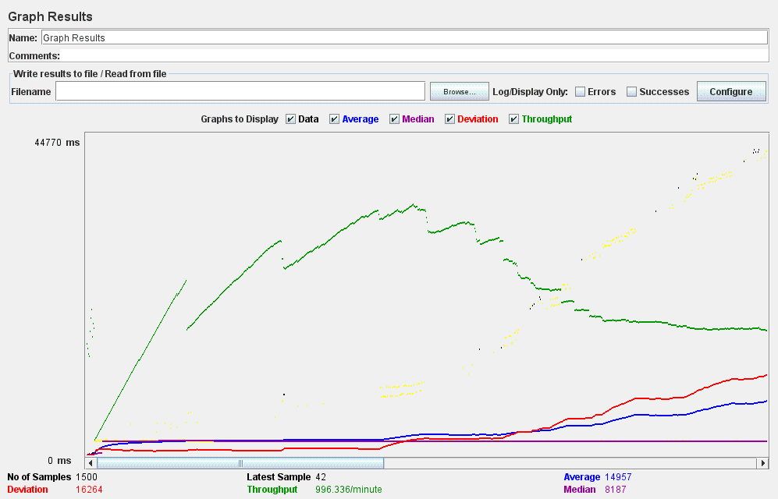

Figure 28: Graph Results

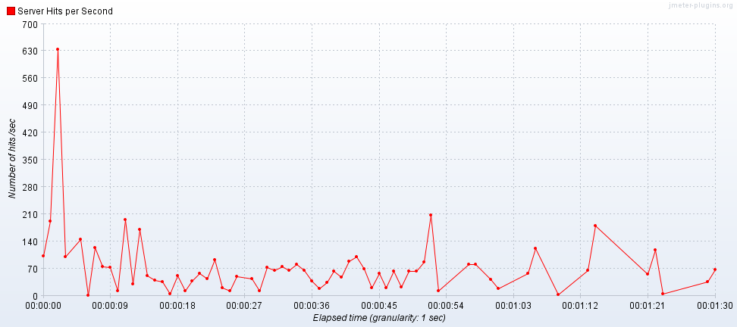

Figure 29: Hits per Second

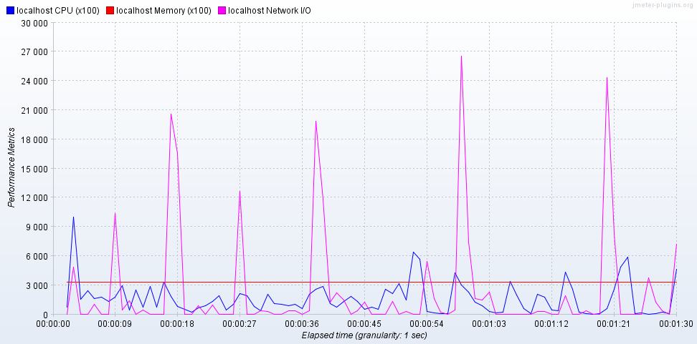

Figure 30: PerfMon Metrics Collector

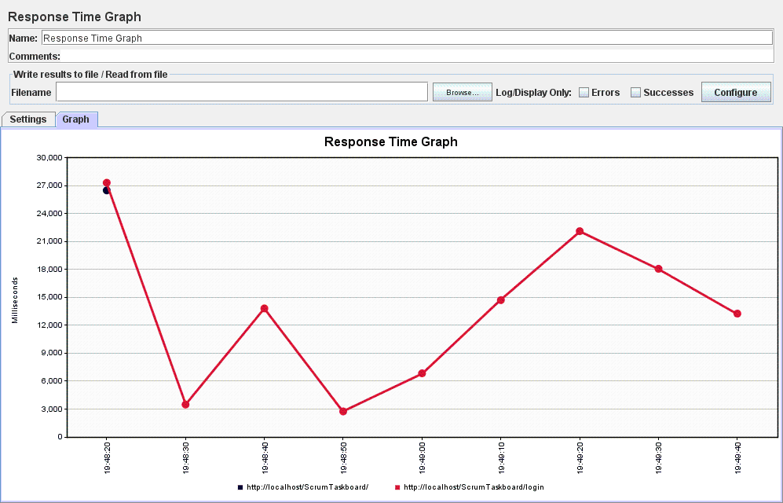

Figure 31: Response Time Graph

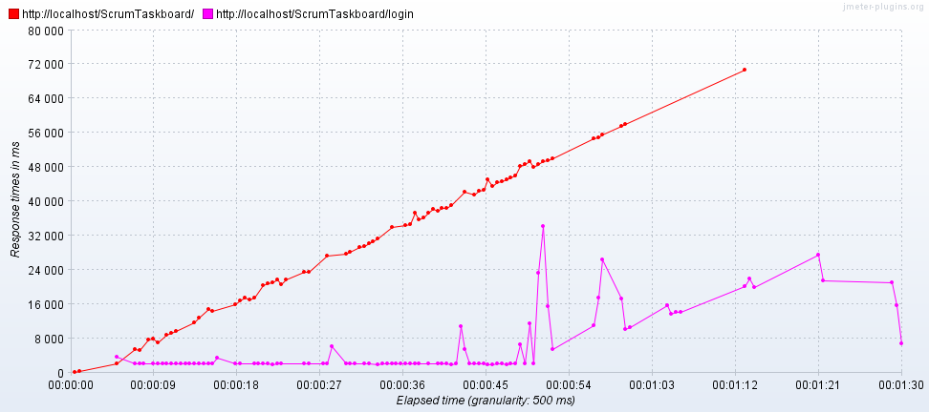

Figure 32: Response Times Over Time

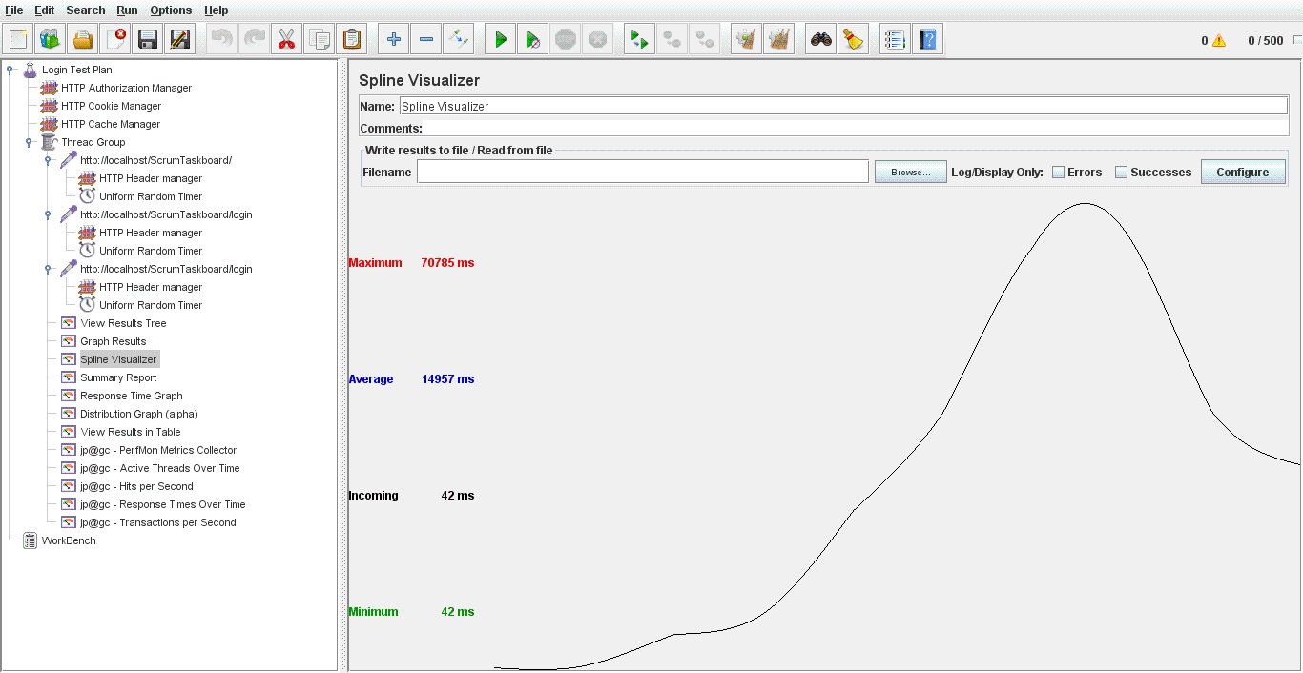

Figure 33: Spline Visualizer

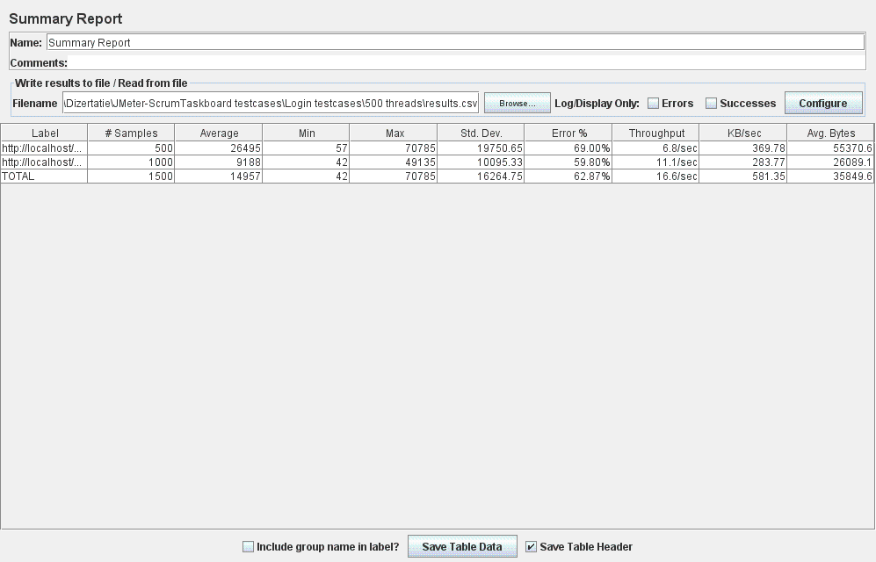

Figure 34: Summary Report

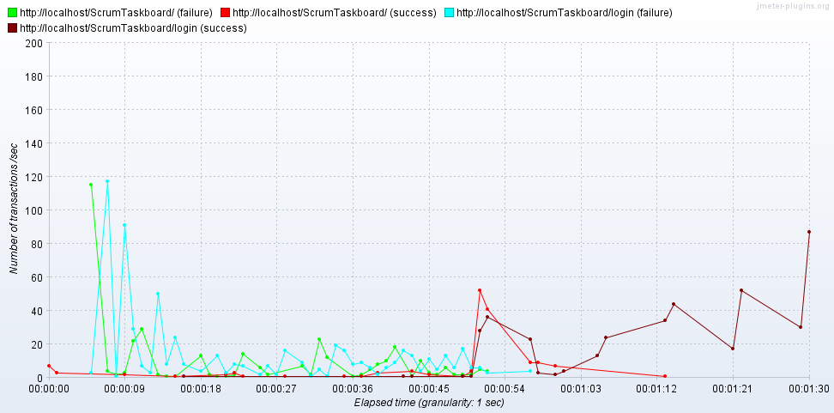

Figure 35: Transactions per Second

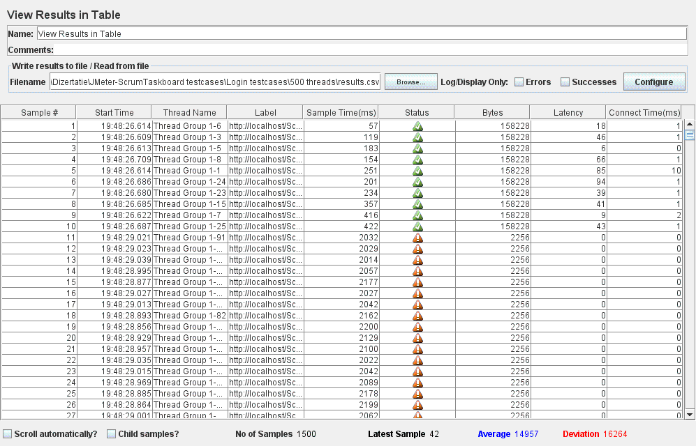

Figure 36: View Results in Table

* For the **Register User** test case:
* The application responds successfully to 100 concurrent users (threads This result is recorded in the images listed below which were obtained from different measurements:

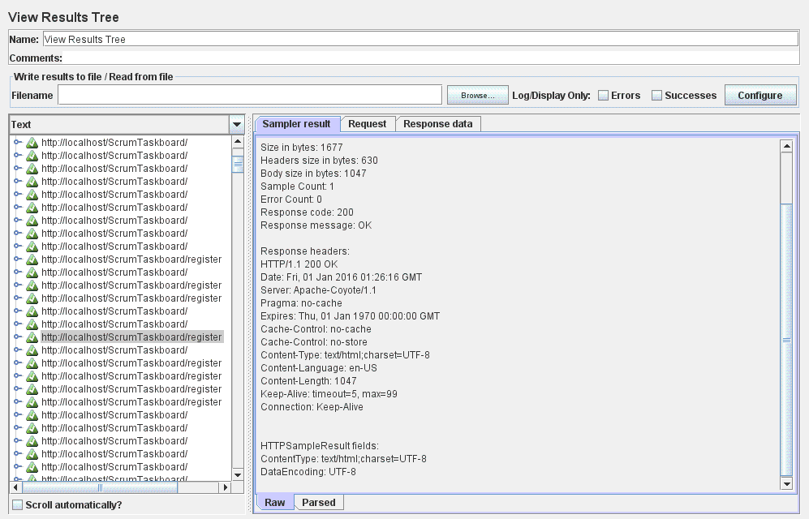

Figure 37: View Results Tree

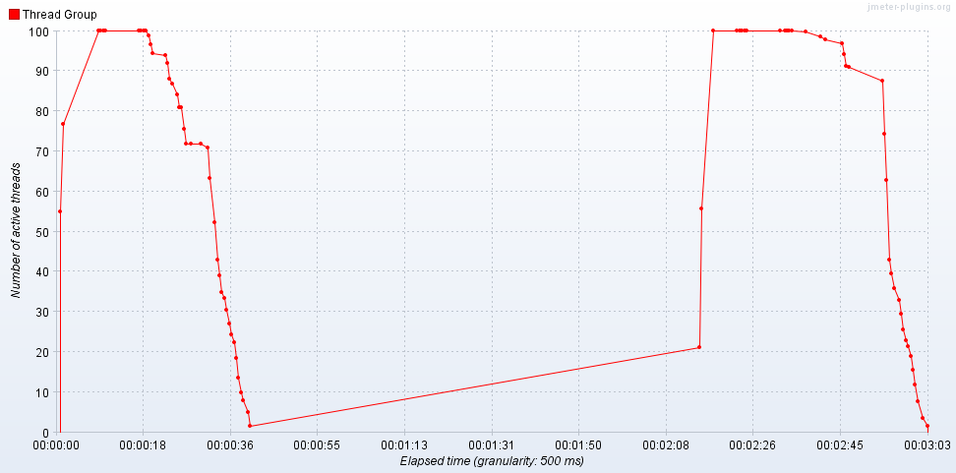

Figure 38: Active Threads Over Time

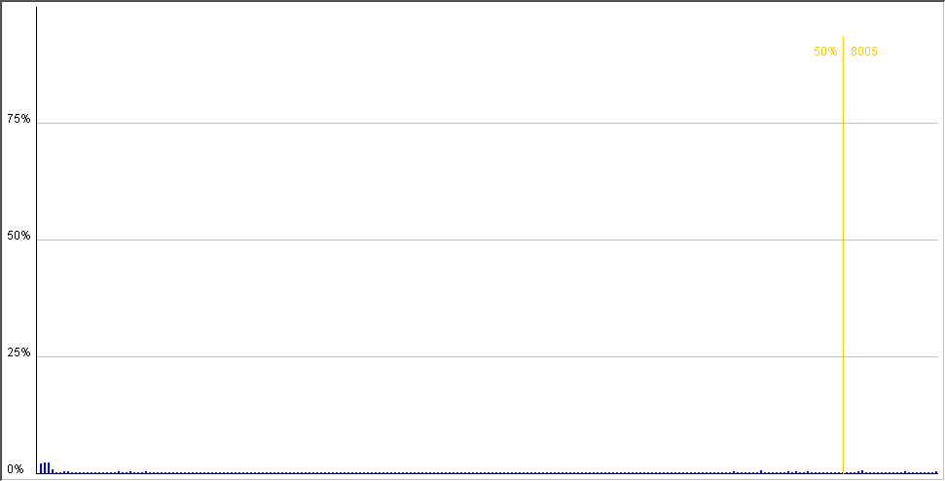

Figure 39: Distribution Graph (alpha)

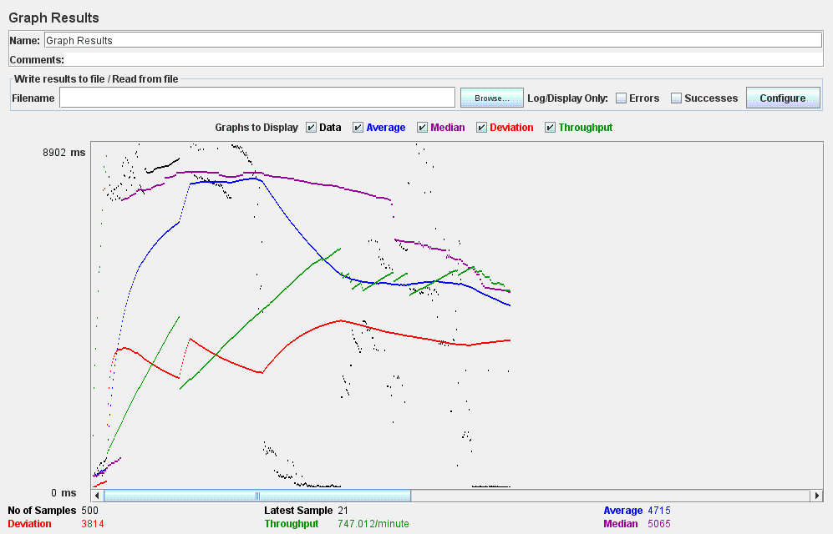

Figure 40: Graph Results

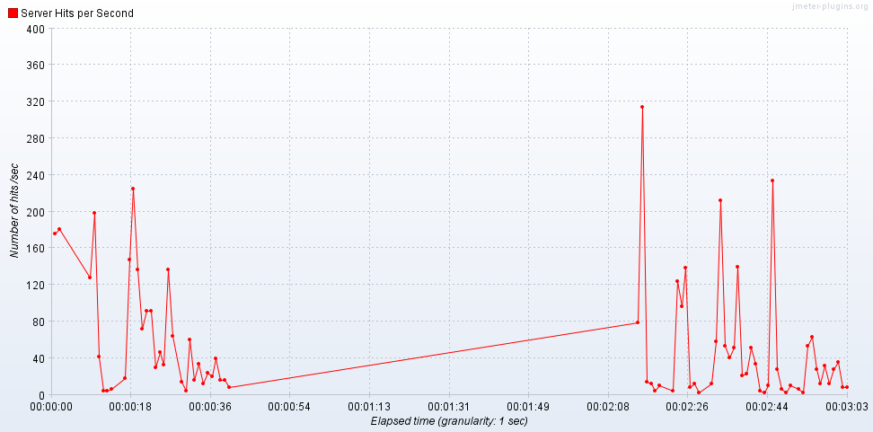

Figure 41: Hits per Second

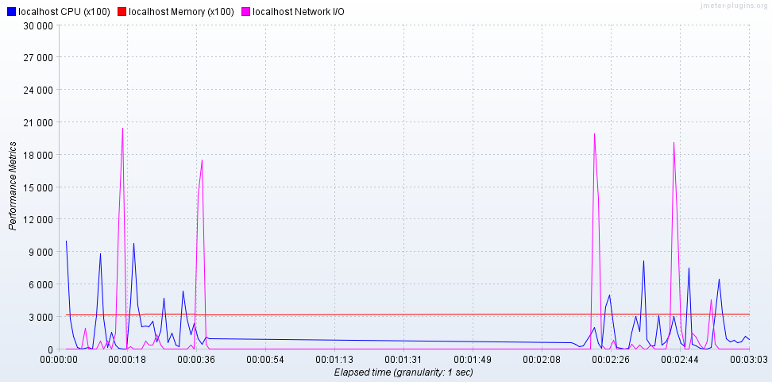

Figure 42: PerfMon Metrics Collector

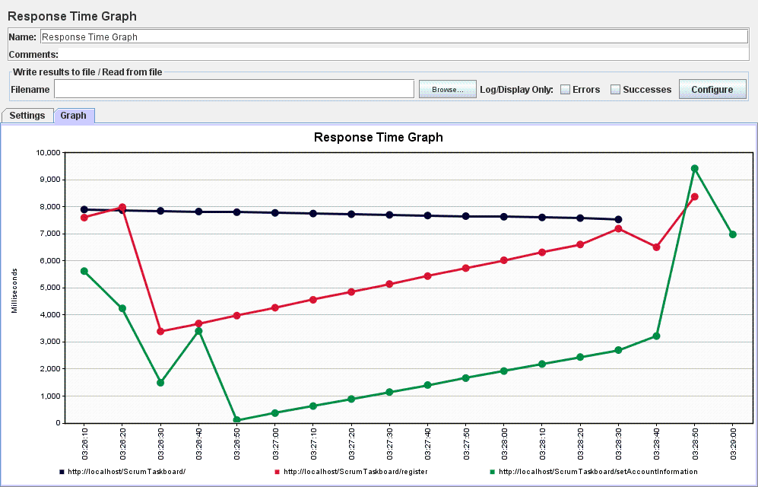

Figure 43: Response Time Graph

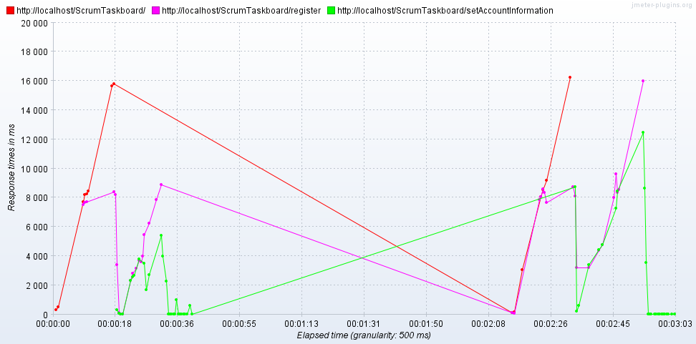

Figure 44: Response Times Over Time

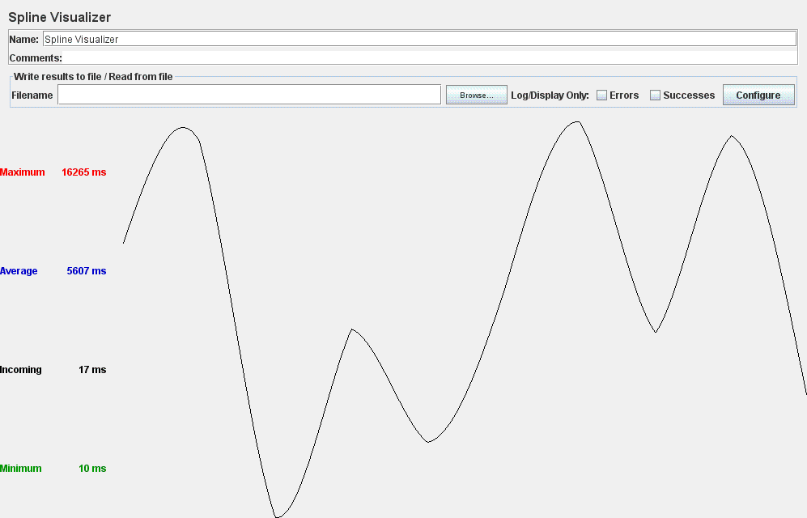

Figure 45: Spline Visualizer

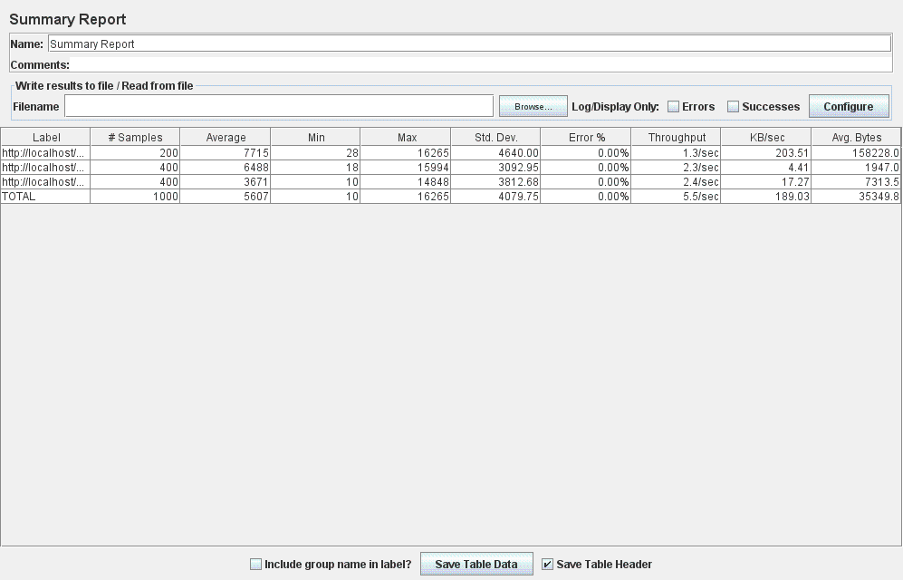

Figure 46: Summary Report

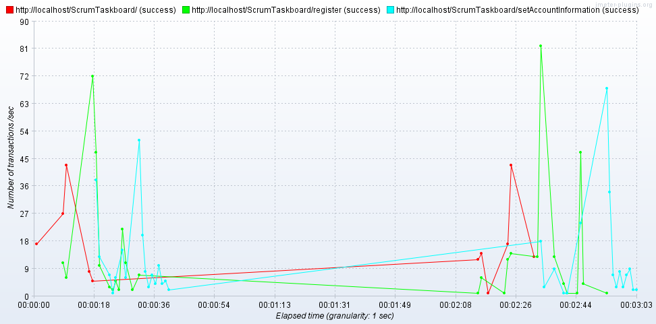

Figure 47: Transactions per Second

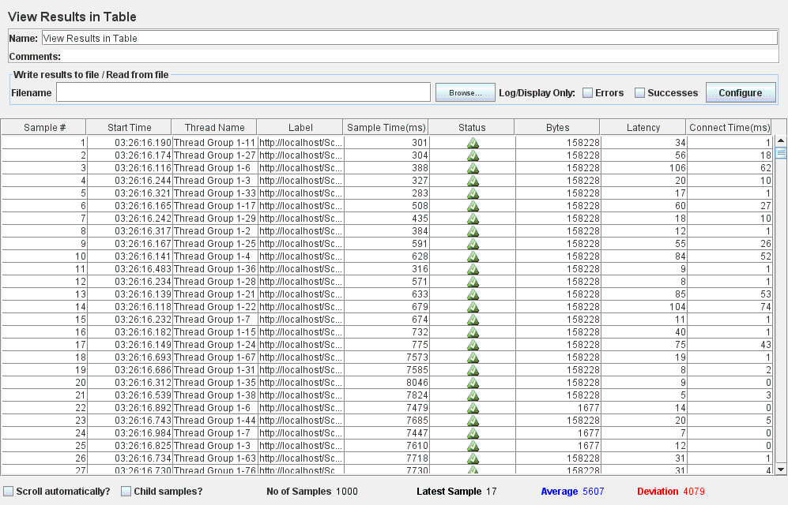

Figure 48: View Results in Table

* The application responds is unable to successfully handle a number of 300 concurrent users (threads) attempting to register. The results obtained from a series of measurements performed show several requests for which the application responded with error.

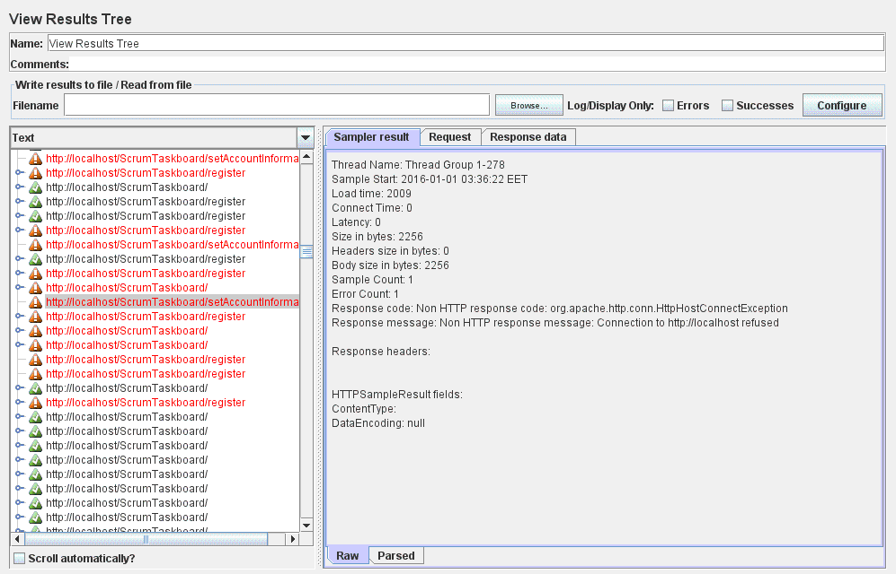

Figure 49: View Results Tree

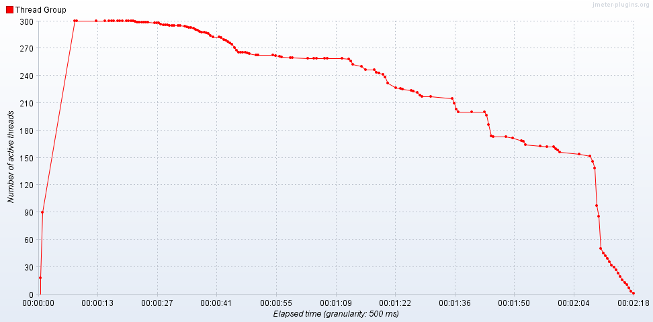

Figure 50: Active Threads Over Time

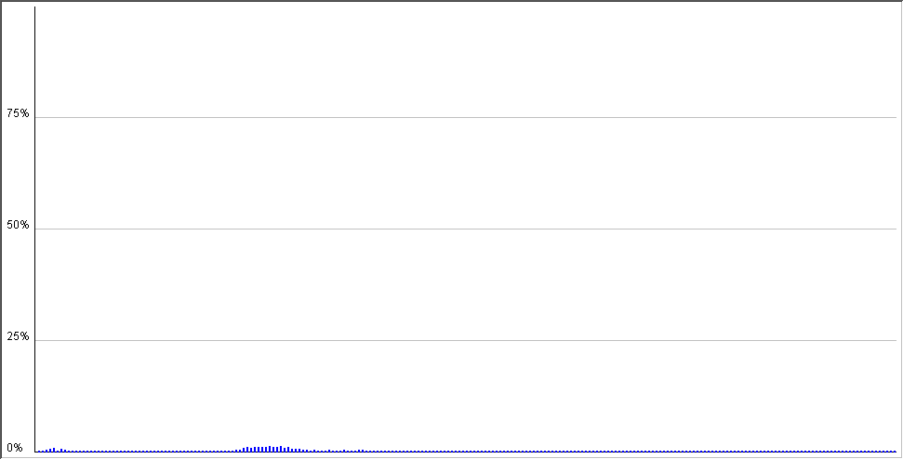

Figure 51: Distribution Graph (alpha)

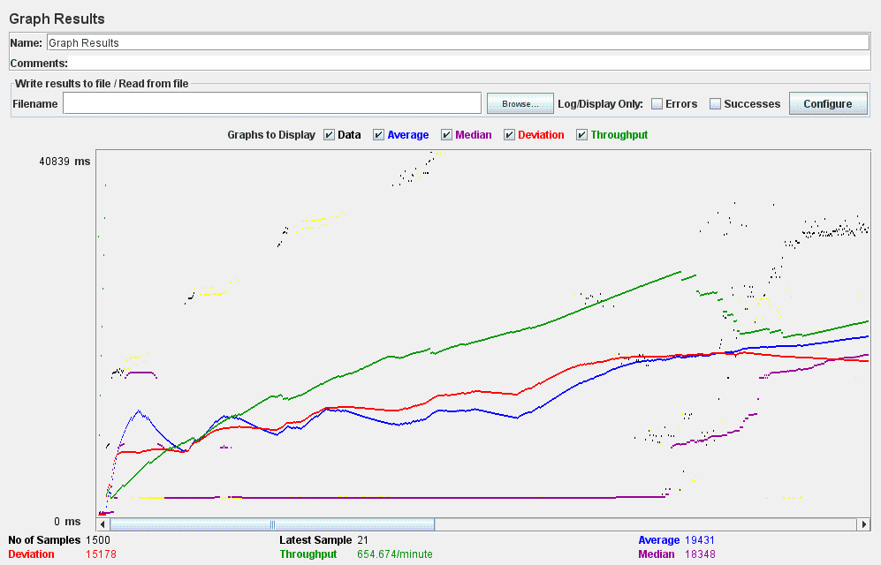

Figure 52: Graph Results

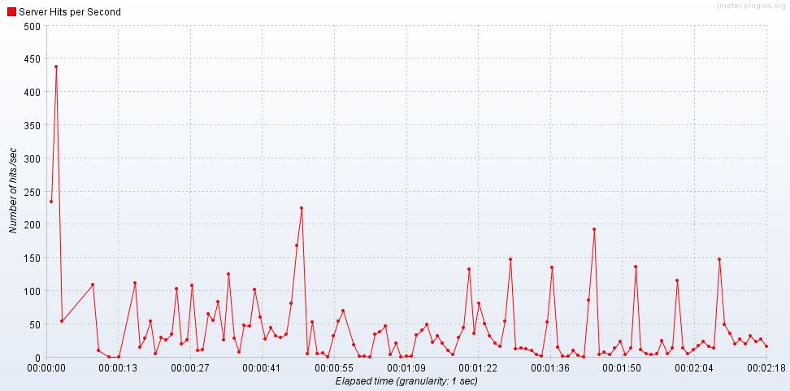

Figure 53: Hits per Second

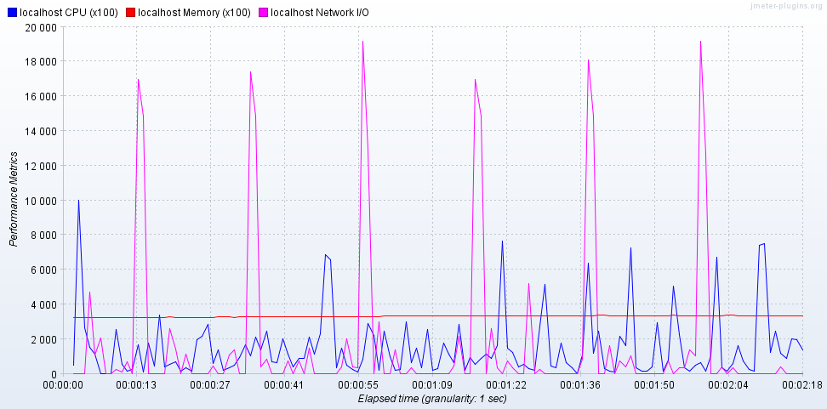

Figure 54: PerfMon Metrics Collector

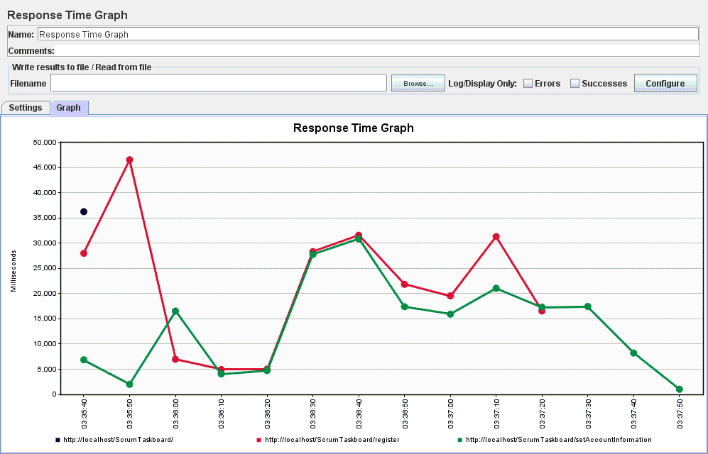

Figure 55: Response Time Graph

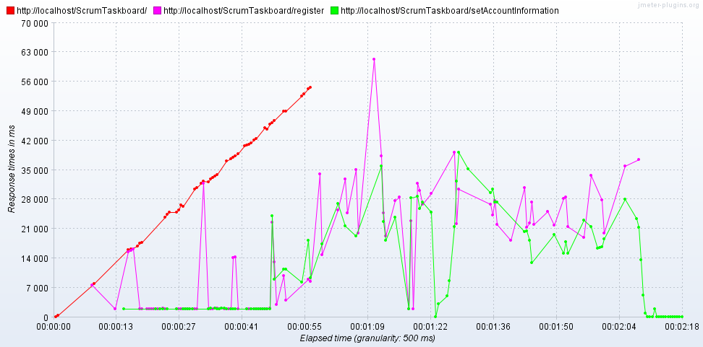

Figure 56: Response Times Over Time

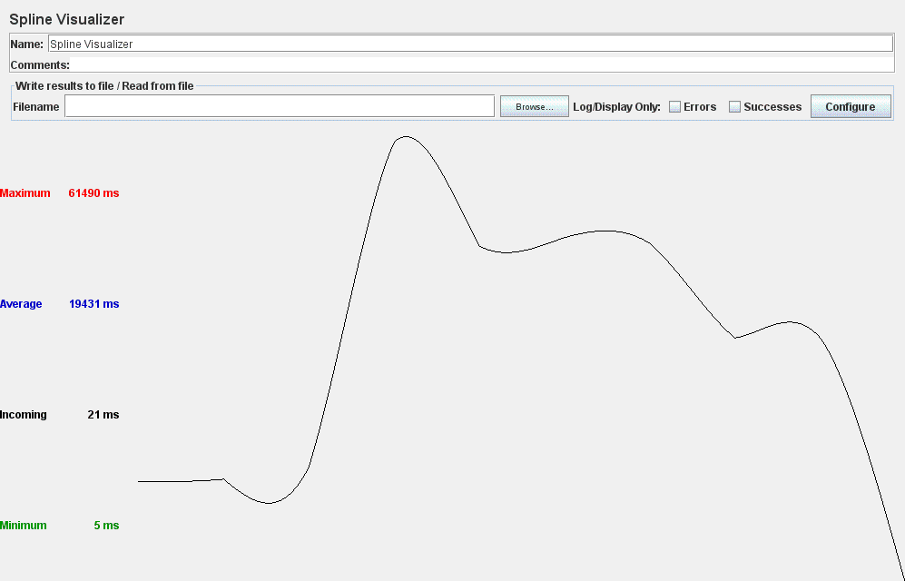

Figure 57: Spline Visualizer

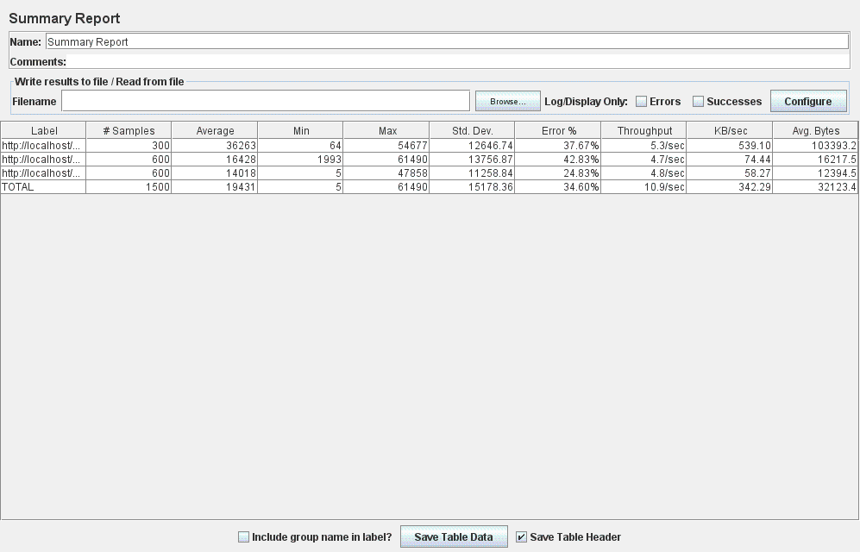

Figure 58: Summary Report

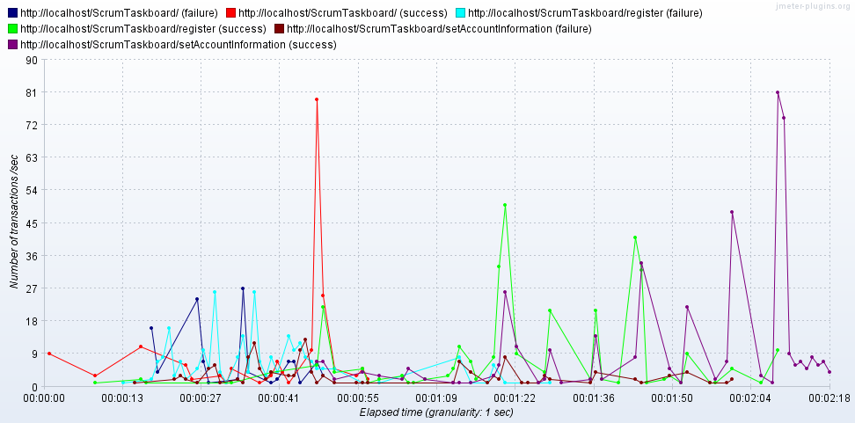

Figure 59: Transactions per Second

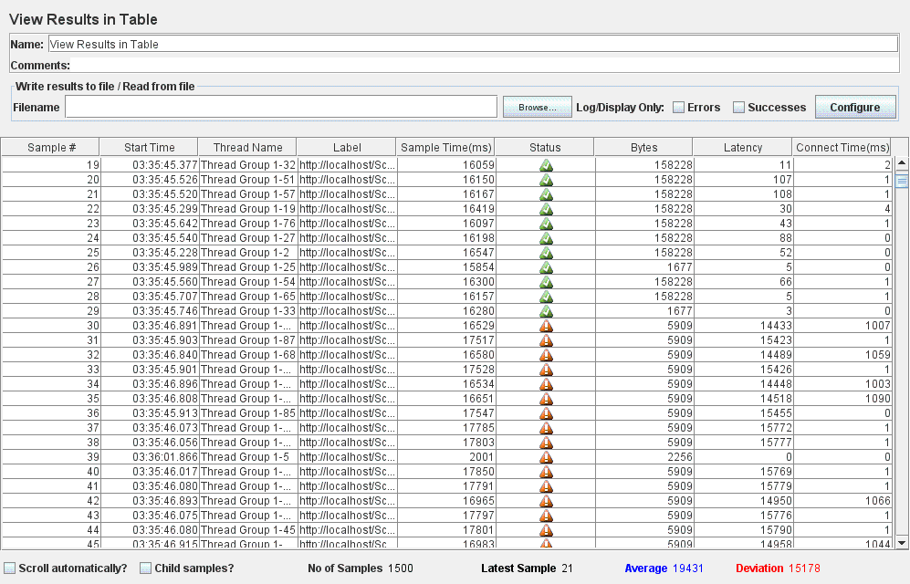

Figure 60: View Results in Table

* Even worst results are obtained when a number of 500 users (threads) try to simultaneously register in the ScrumTaskboard web application. The faulty behavior of the application for this case scenario is denoted by the pictures obtained by performing a series of metrics on the test case:

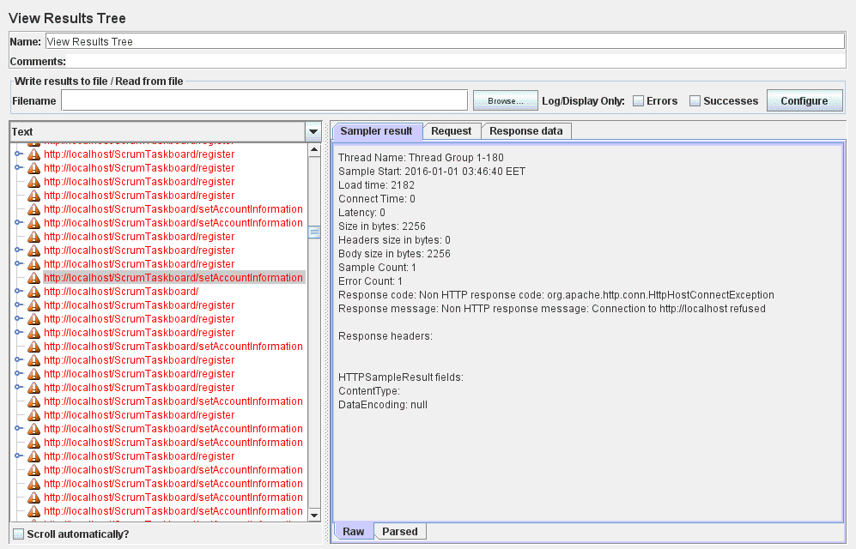

Figure 61: View Results Tree

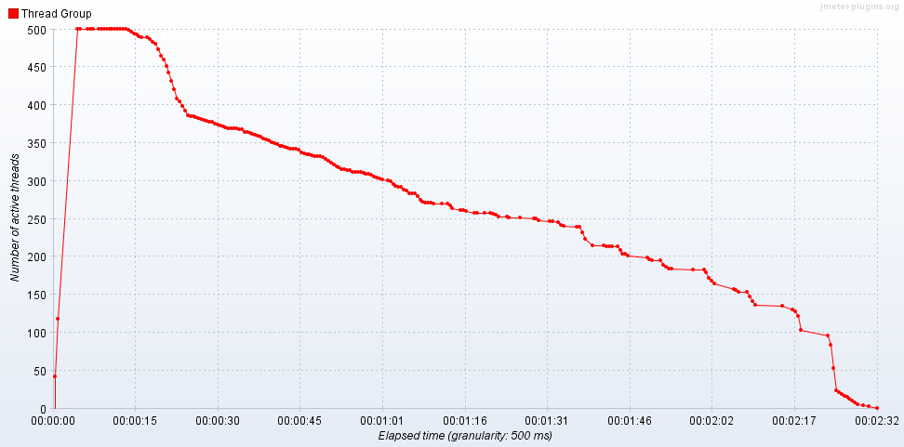

Figure 62: Active Threads Over Time

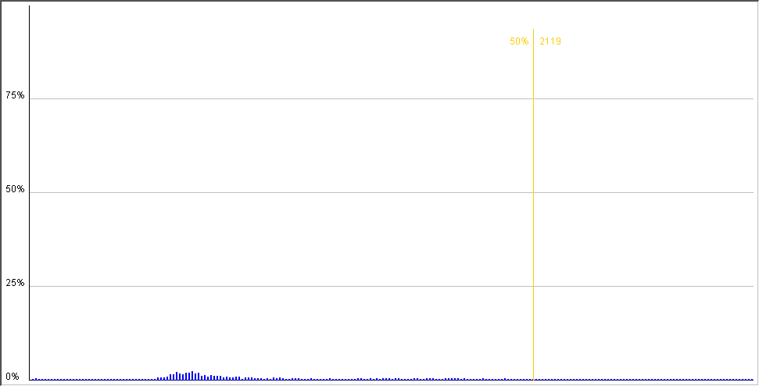

Figure 63: Distribution Graph (alpha)

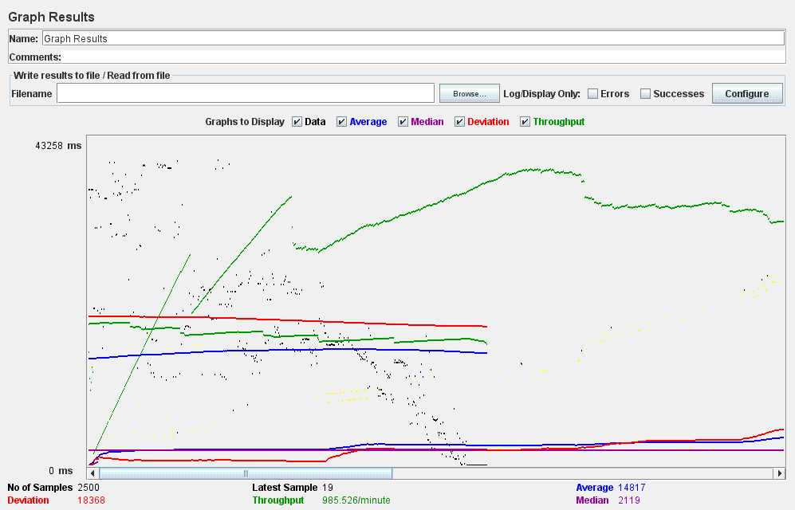

Figure 64: Graph Results

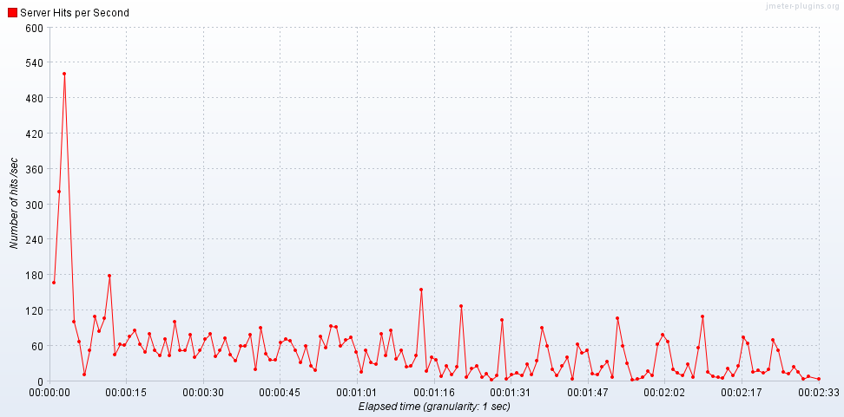

Figure 65: Hits per Second

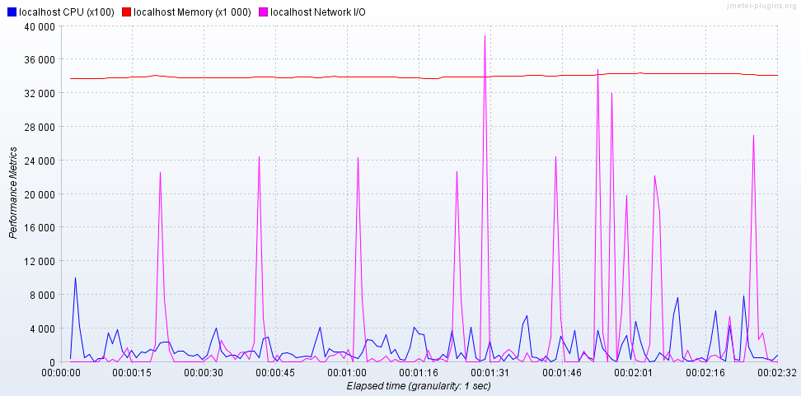

Figure 66: PerfMon Metrics Collector

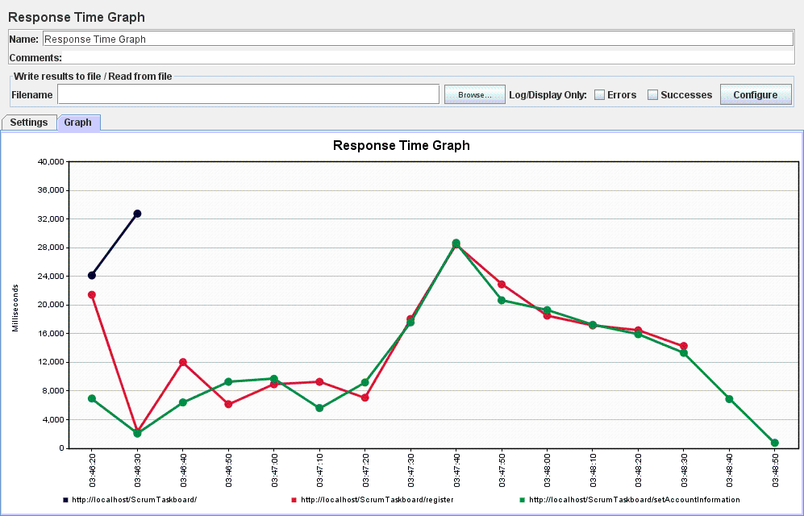

Figure 67: Response Time Graph

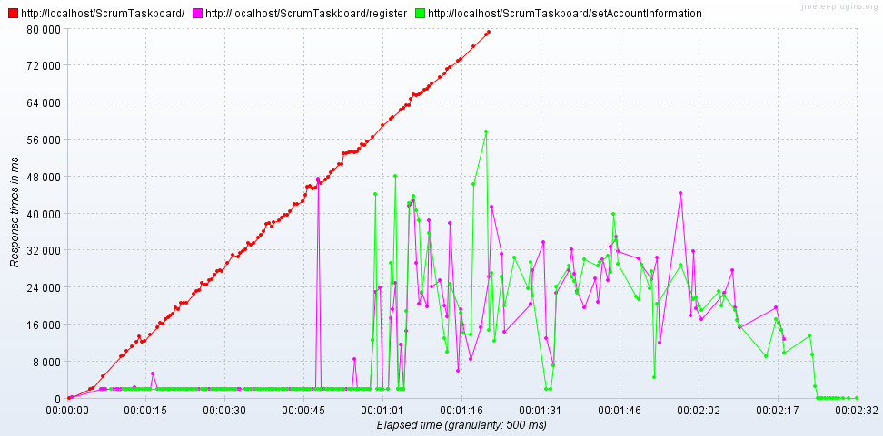

Figure 68: Response Times Over Time

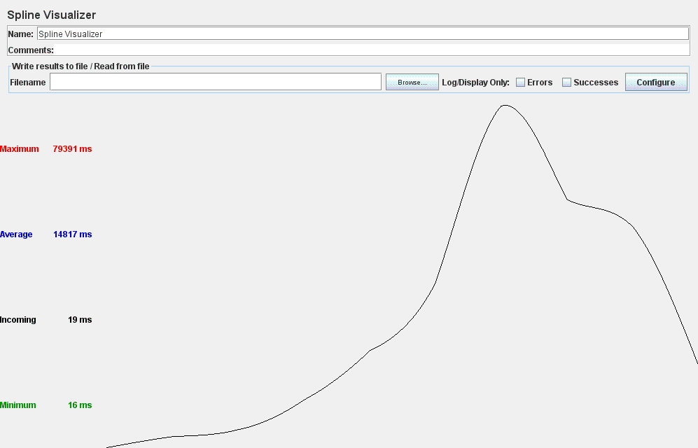

Figure 69: Spline Visualizer

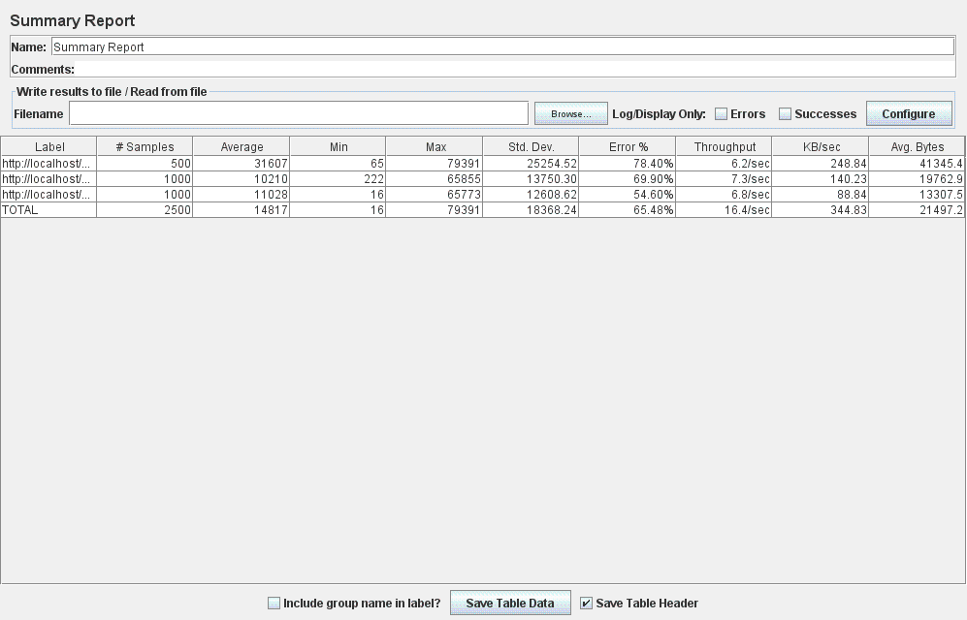

Figure 70: Summary Report

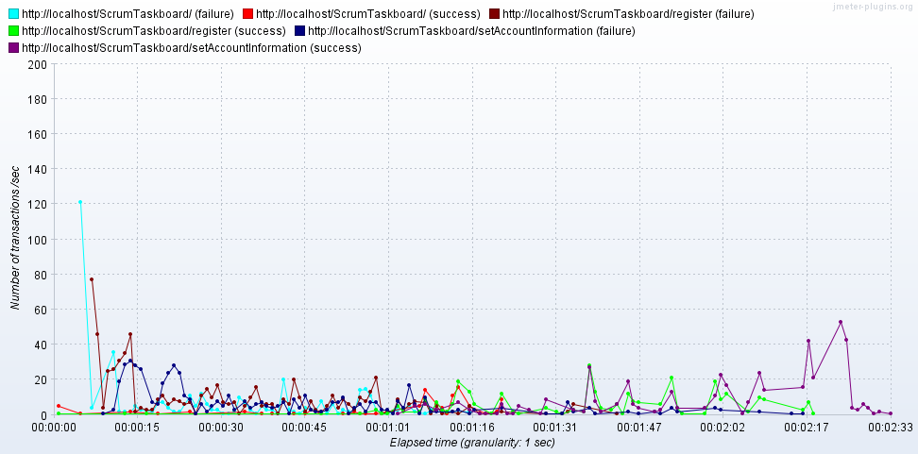

Figure 71: Transactions per Second

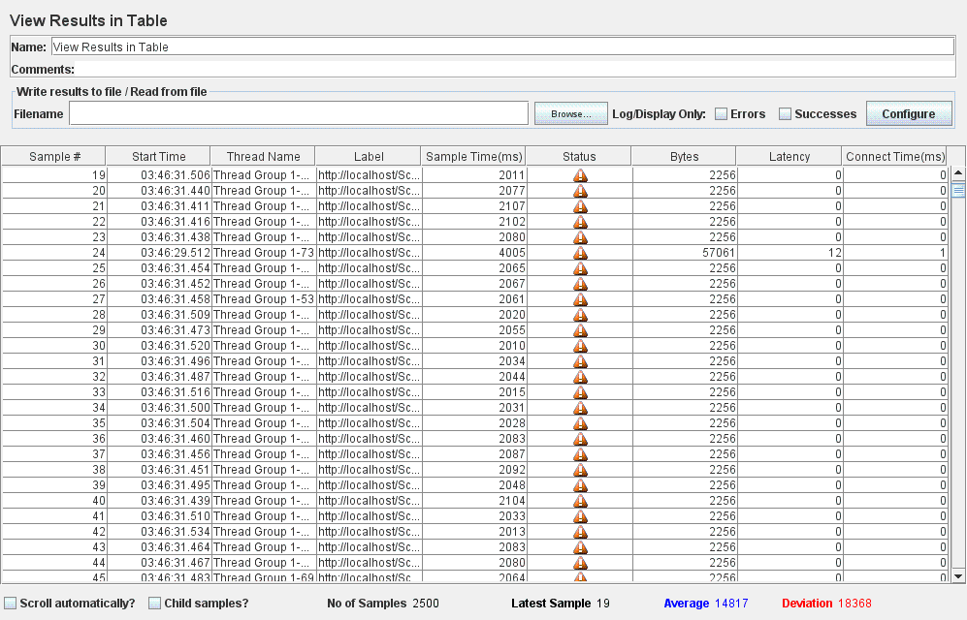

Figure 72: View Results in Table

* For the **Login-Visualize Taskboard-Logout** test case:
* The application responds successfully to 100 concurrent users (threads) trying to simultaneously log in, visualize the taskboard and log out. This result is recorded in the images listed below which were obtained from different measurements:

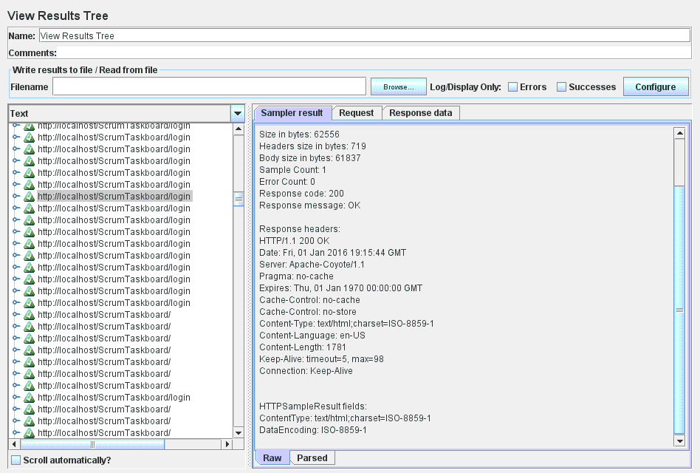

Figure 73: View Results Tree

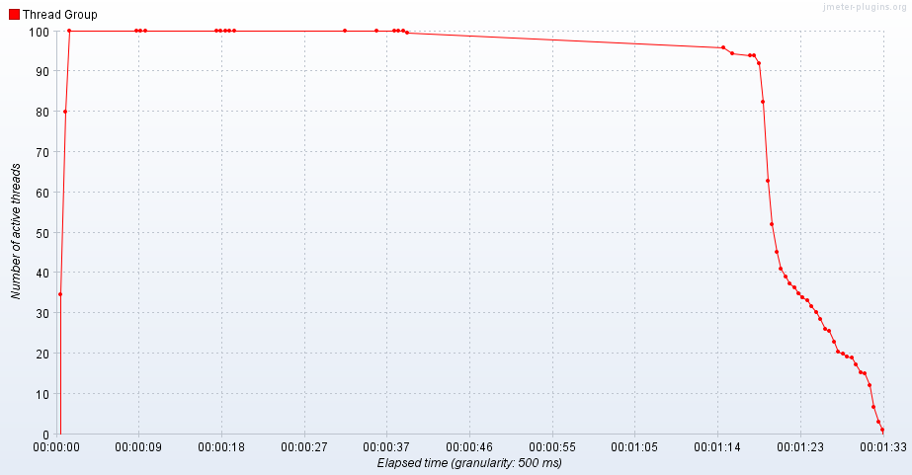

Figure 74: Active Threads Over Time

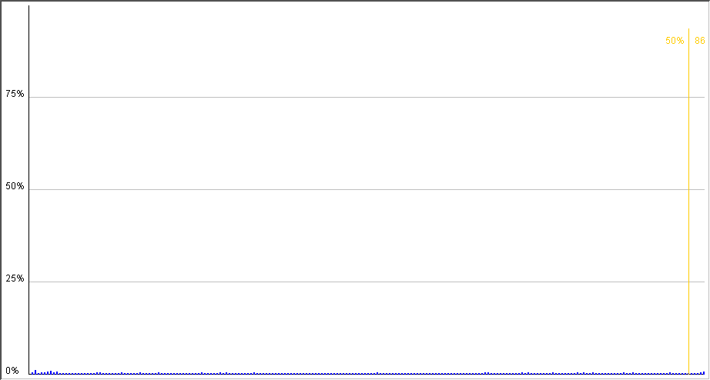

Figure 75: Distribution Graph (alpha)

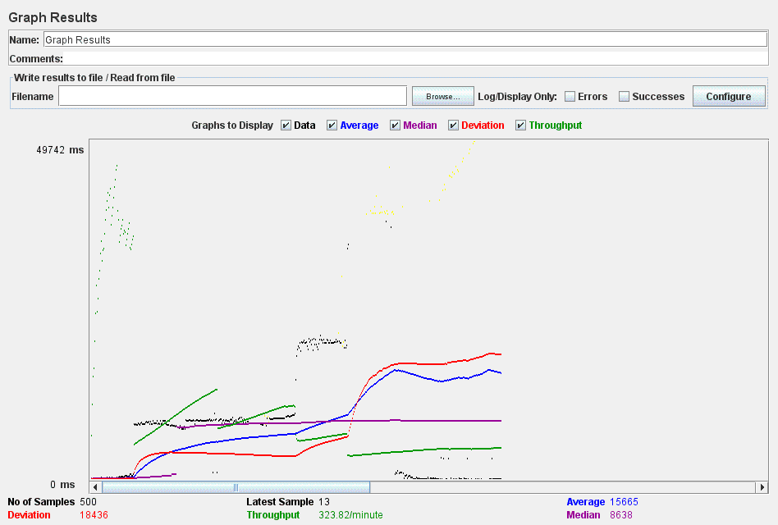

Figure 76: Graph Results

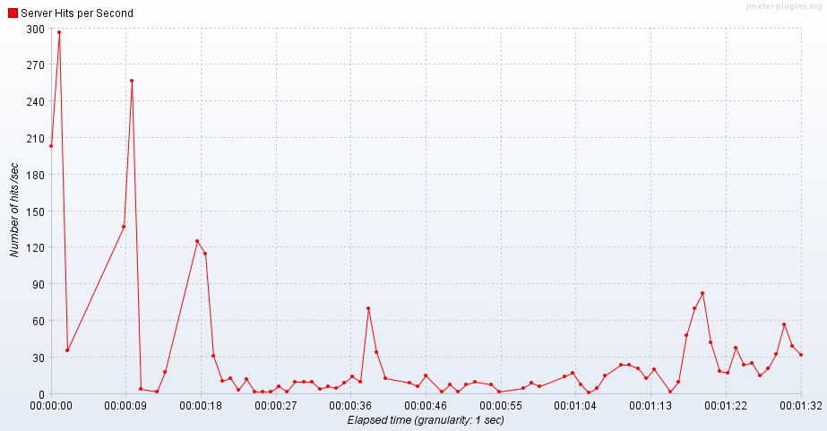

Figure 77: Hits per Second

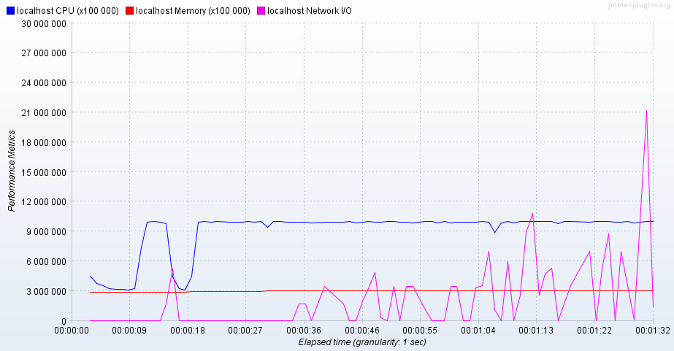

Figure 78: PerfMon Metrics Collector

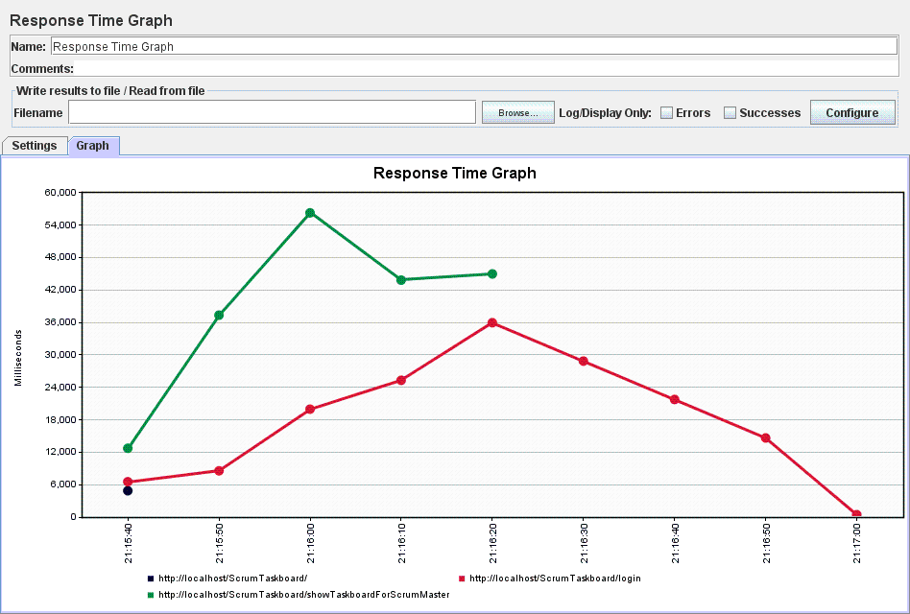

Figure 79: Response Time Graph

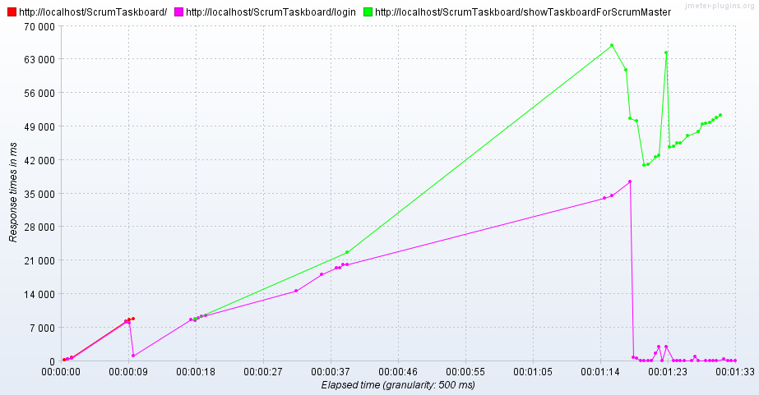

Figure 80: Response Times Over Time

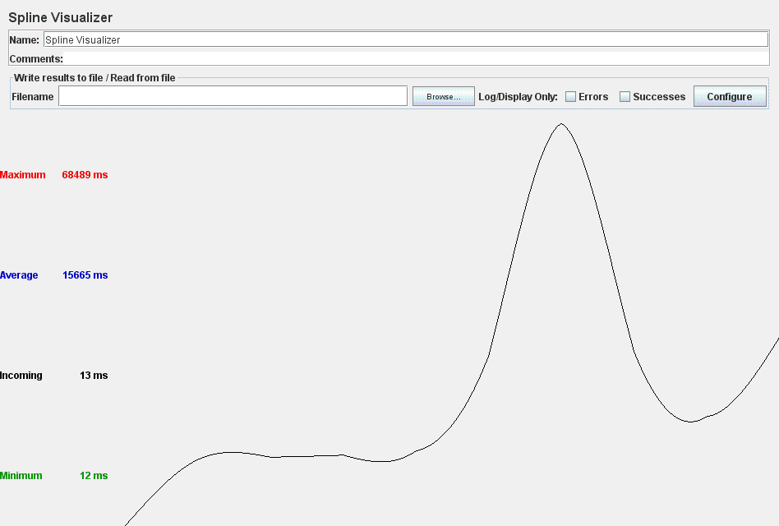

Figure 81: Spline Visualizer

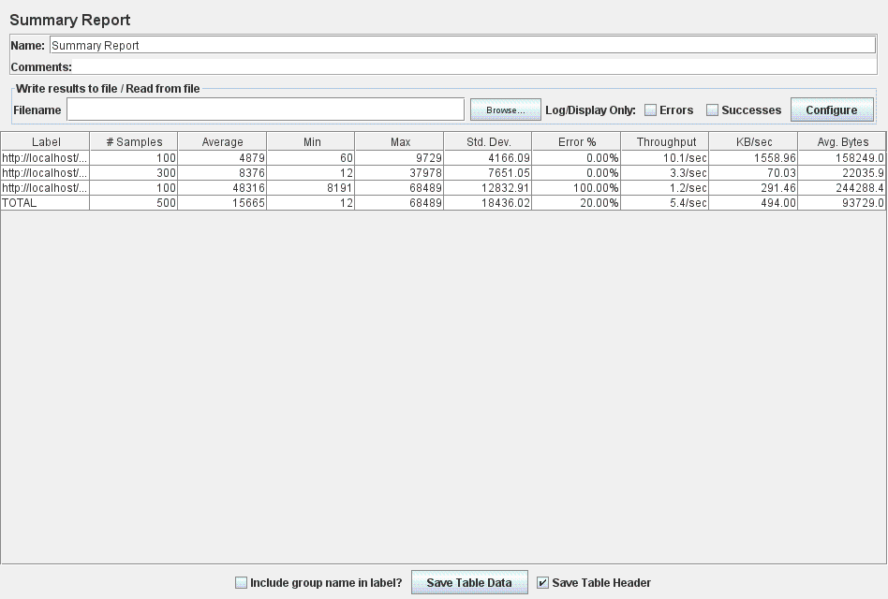

Figure 82: Summary Report

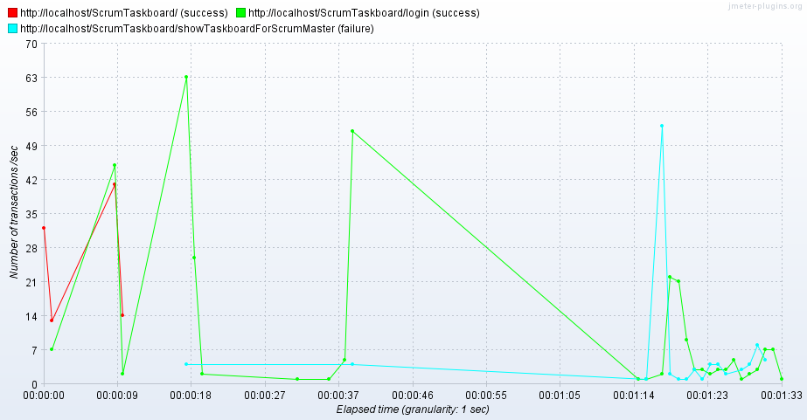

Figure 83: Transactions per Second

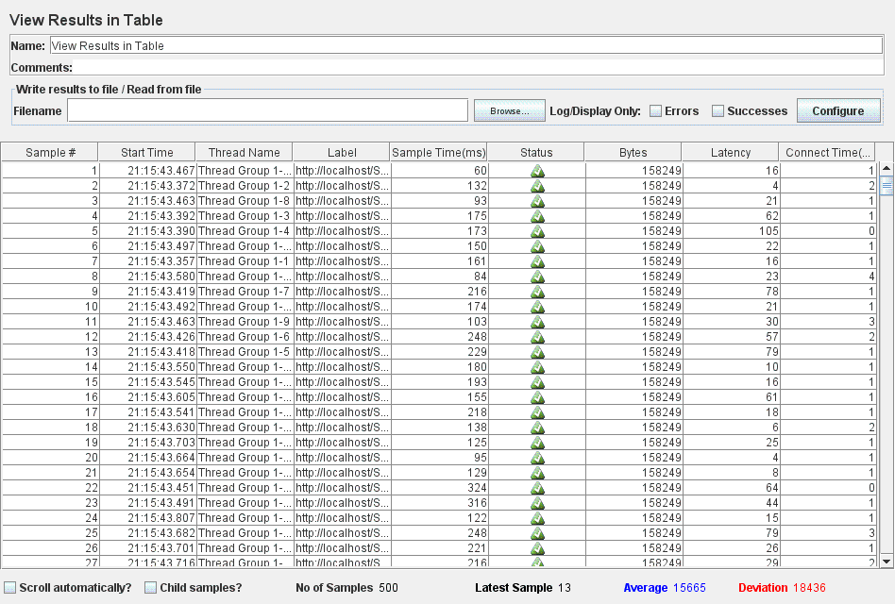

Figure 84: View Results in Table

* The ScrumTaskboard web application is almost unresponsive when a number of 300 concurrent users (threads) try to log in, visualize the taskboard and log out. Figure 85 listed below shows several requests for which the application responded with error. Additional information might be gathered by analyzing the results obtained from different measurements:

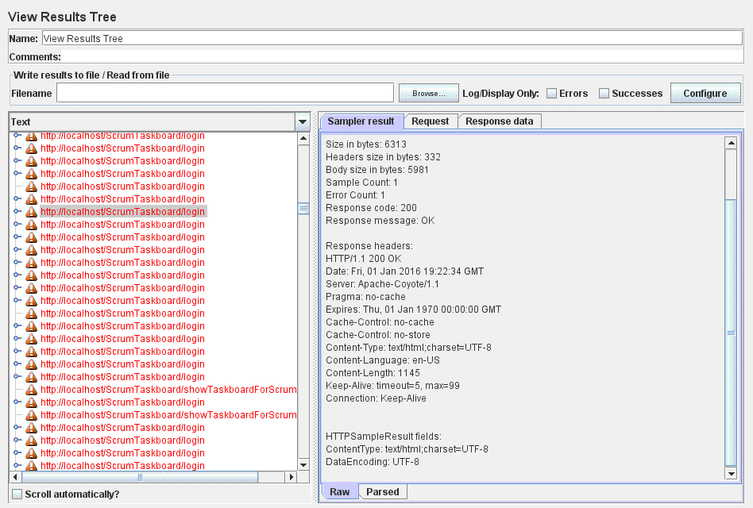

Figure 85: View Results Tree

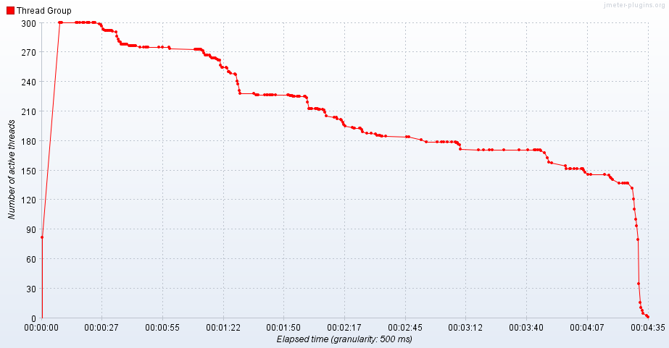

Figure 86: Active Threads Over Time

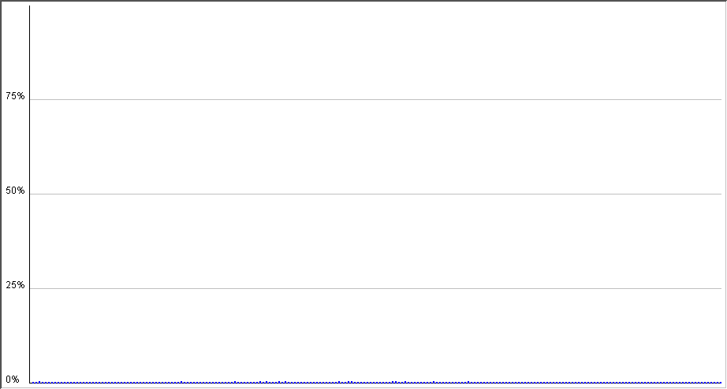

Figure 87: Distribution Graph (alpha)

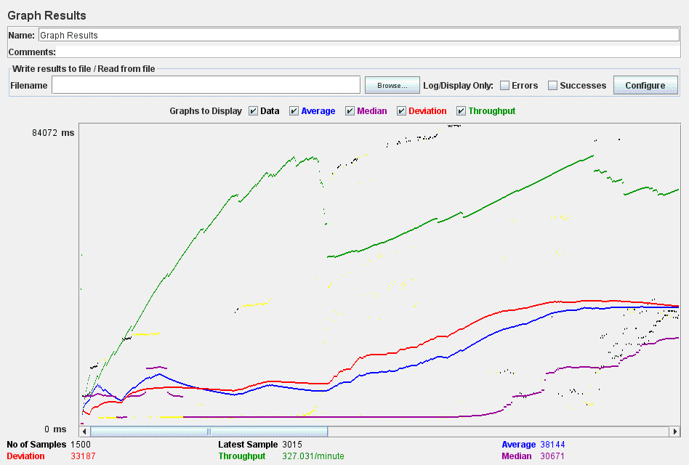

Figure 88: Graph Results

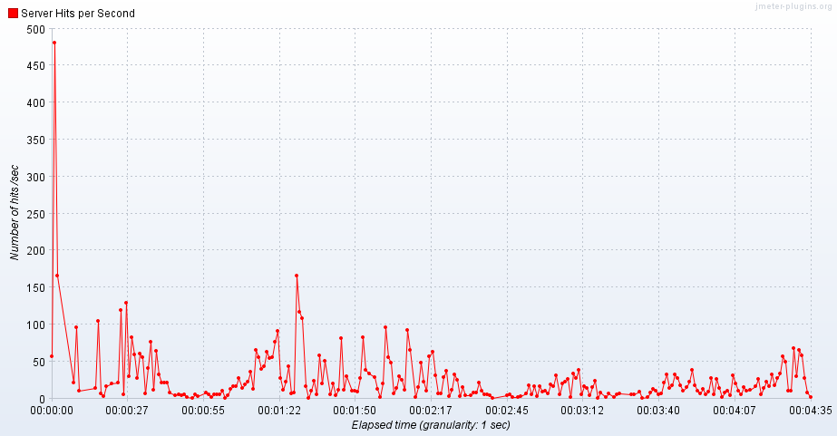

Figure 89: Hits per Second

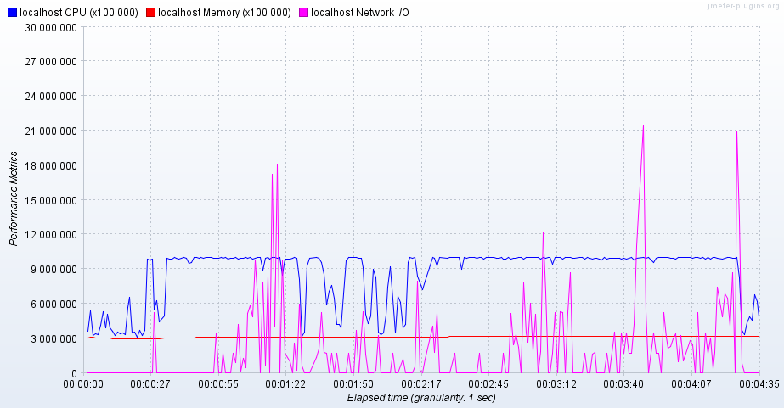

Figure 90: PerfMon Metrics Collector

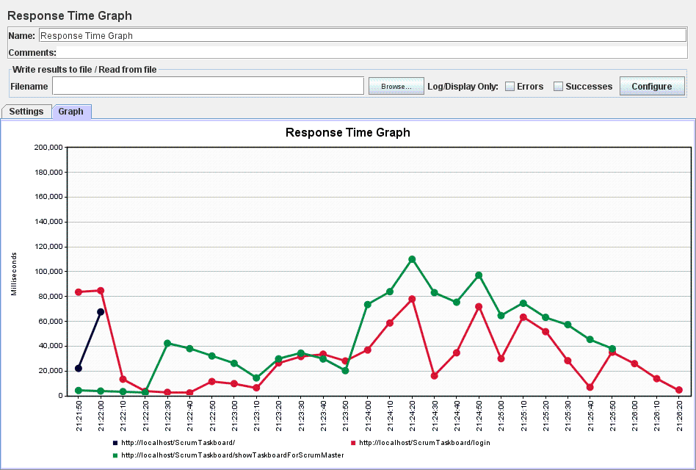

Figure 91: Response Time Graph

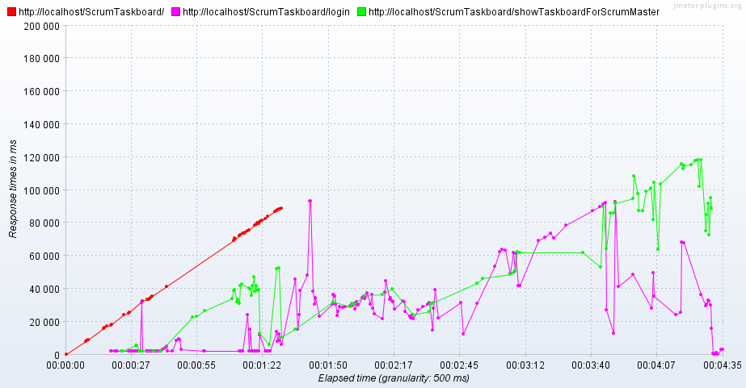

Figure 92: Response Times Over Time

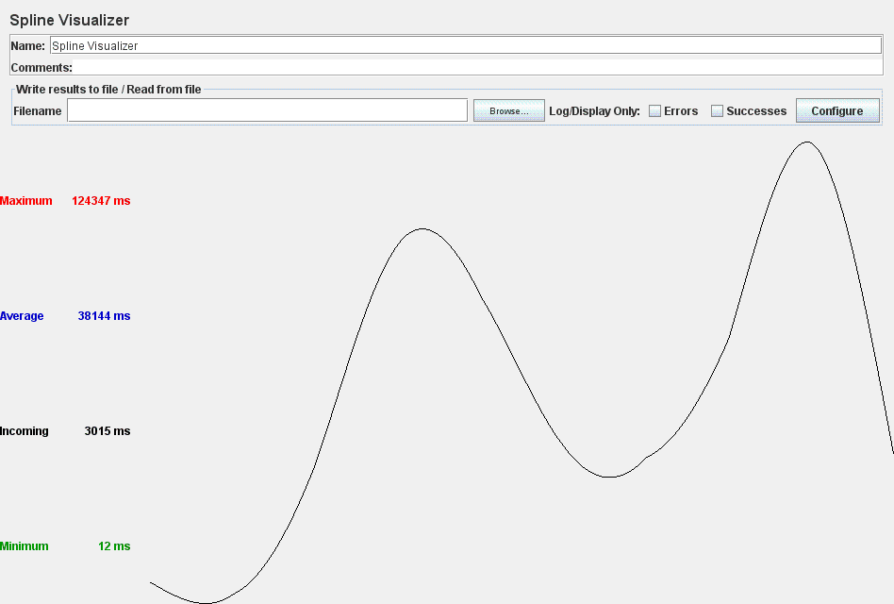

Figure 93: Spline Visualizer

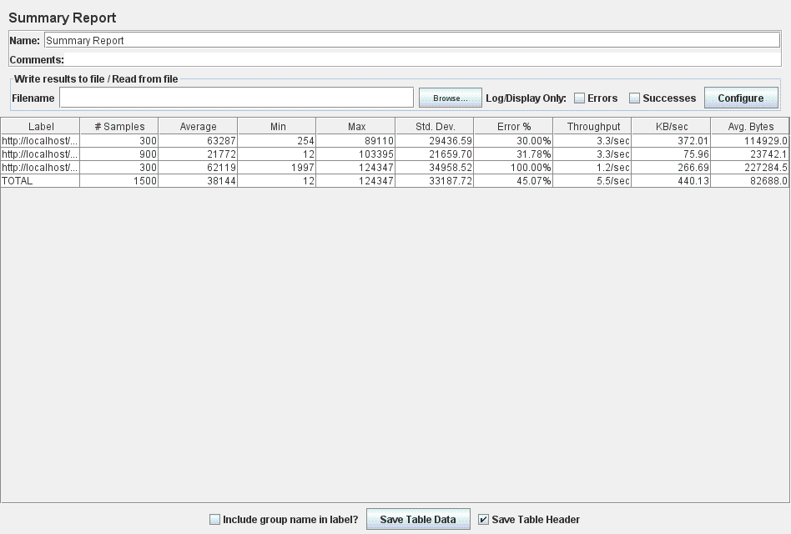

Figure 94: Summary Report

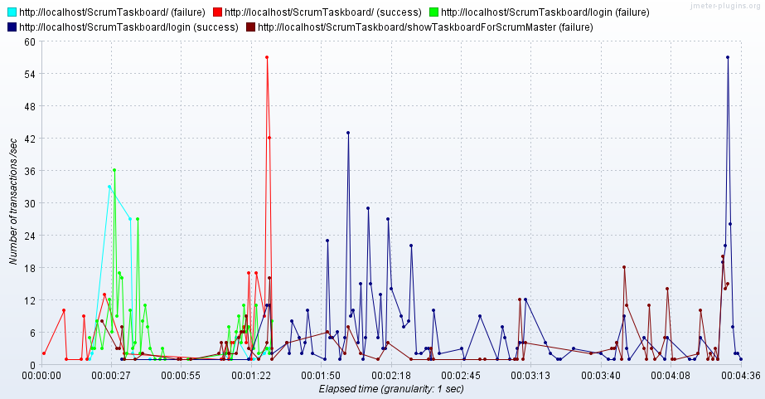

Figure 95: Transactions per Second

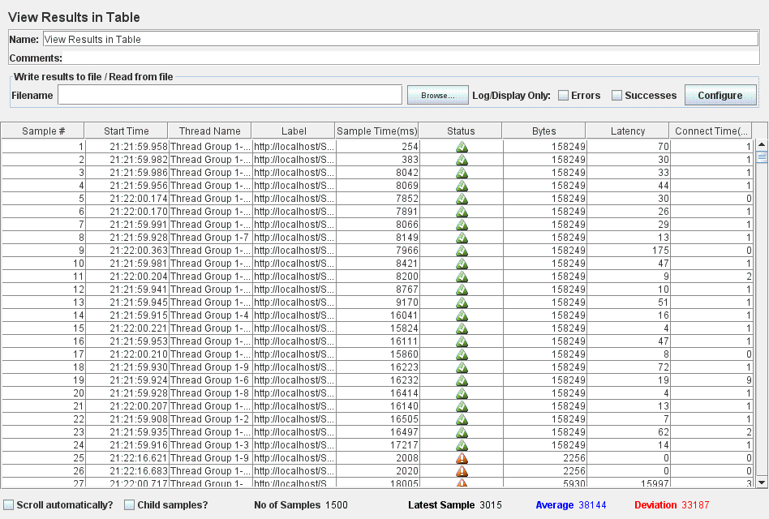

Figure 96: View Results in Table

* For the **Login-Add Task-Add Tag for Task-Visualize Taskboard-Logout** test case:
* The application responds successfully to 100 concurrent users (threads) trying to simultaneously log in, add a new task (as Scrum Master users), add a tag for that task, visualize the taskboard and then log out. This result is recorded in the images listed below which were obtained from different measurements:

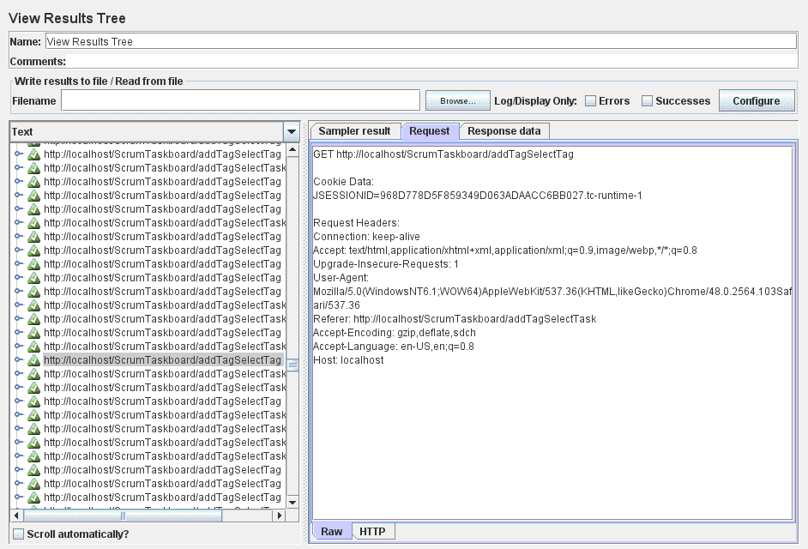

Figure 97: View Results Tree

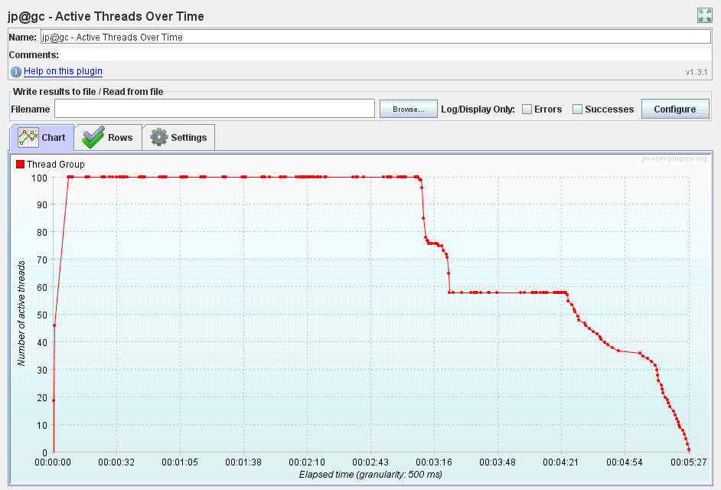

Figure 98: Active Threads Over Time

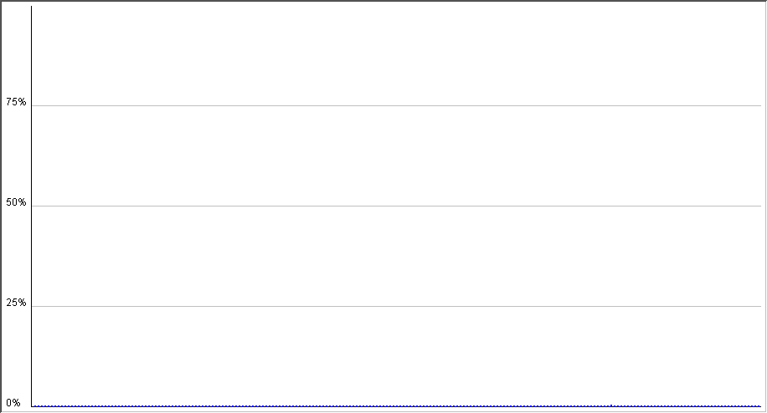

Figure 99: Distribution Graph (alpha)

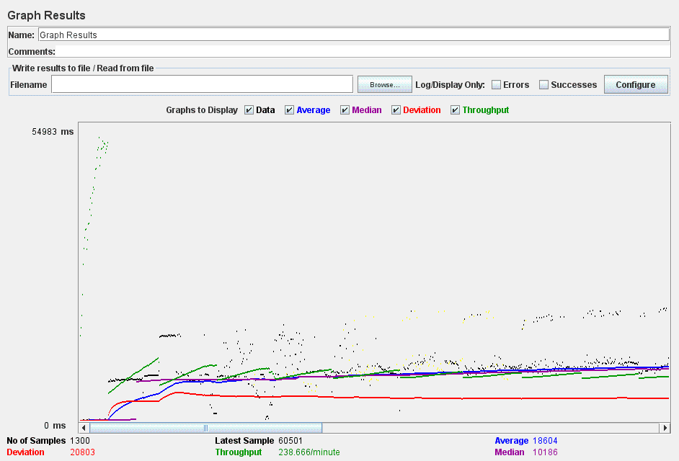

Figure 100: Graph Results

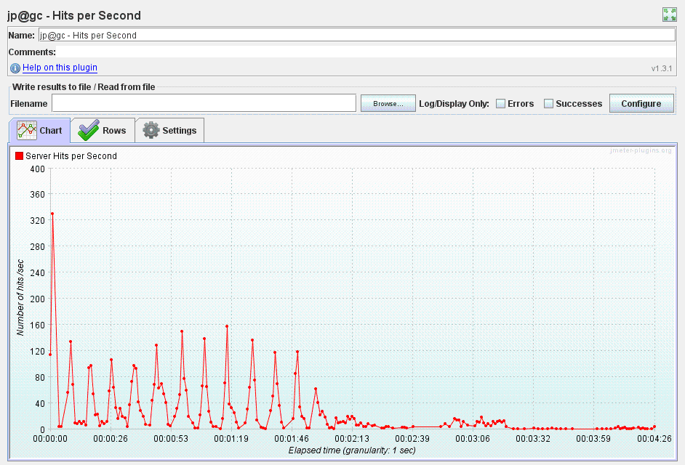

Figure 101: Hits per Second

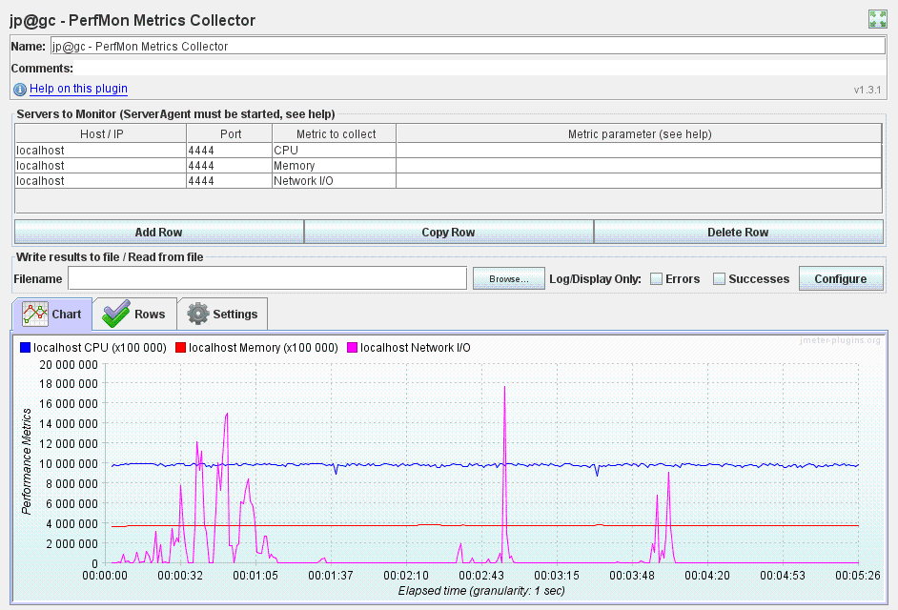

Figure 102: PerfMon Metrics Collector

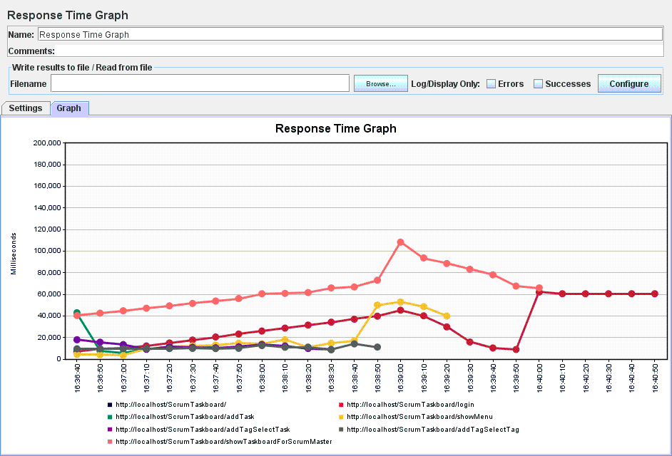

Figure 103: Response Time Graph

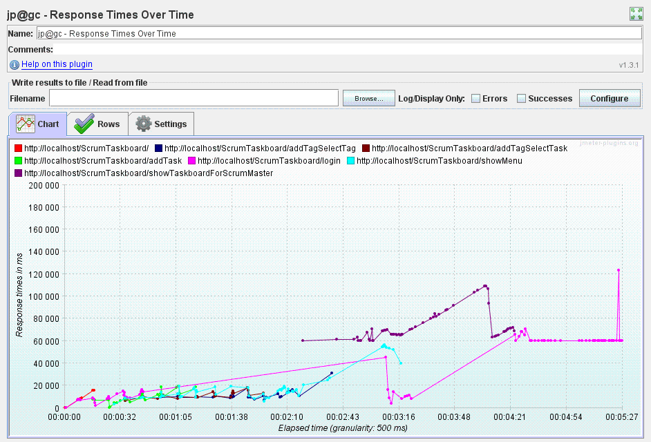

Figure 104: Response Times Over Time

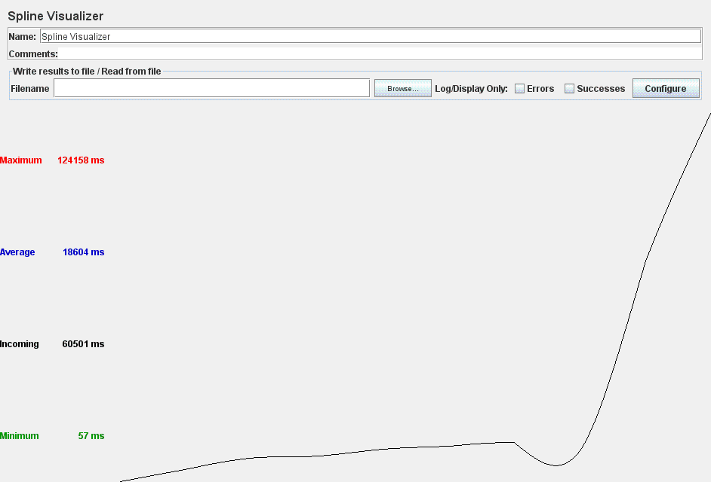

Figure 105: Spline Visualizer

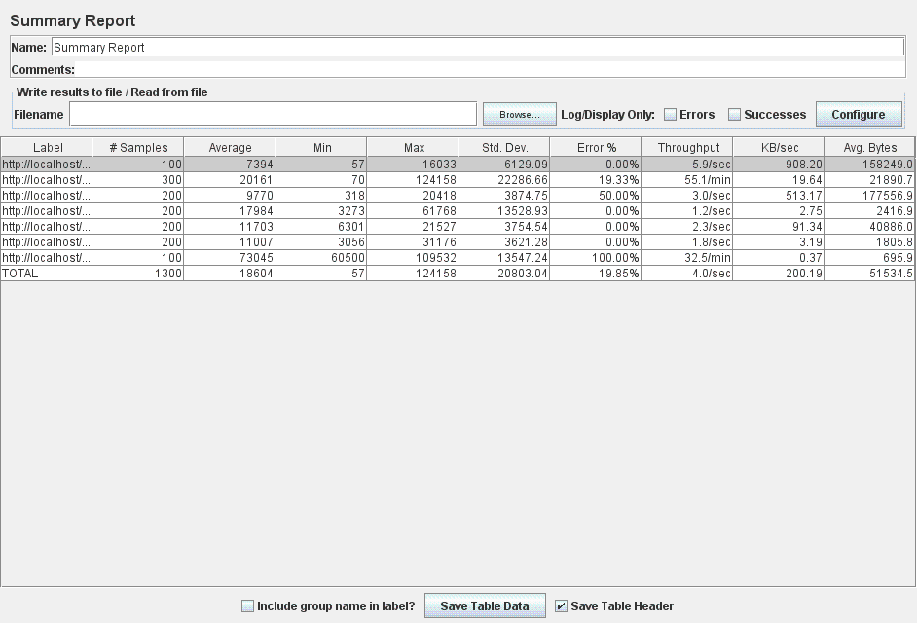

Figure 106: Summary Report

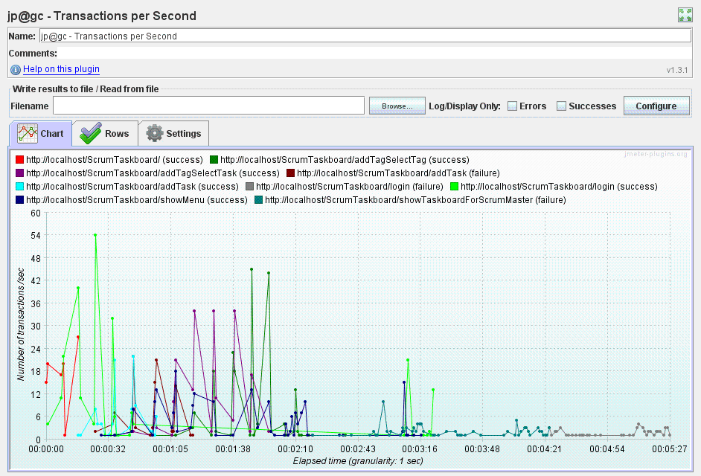

Figure 107: Transactions per Second

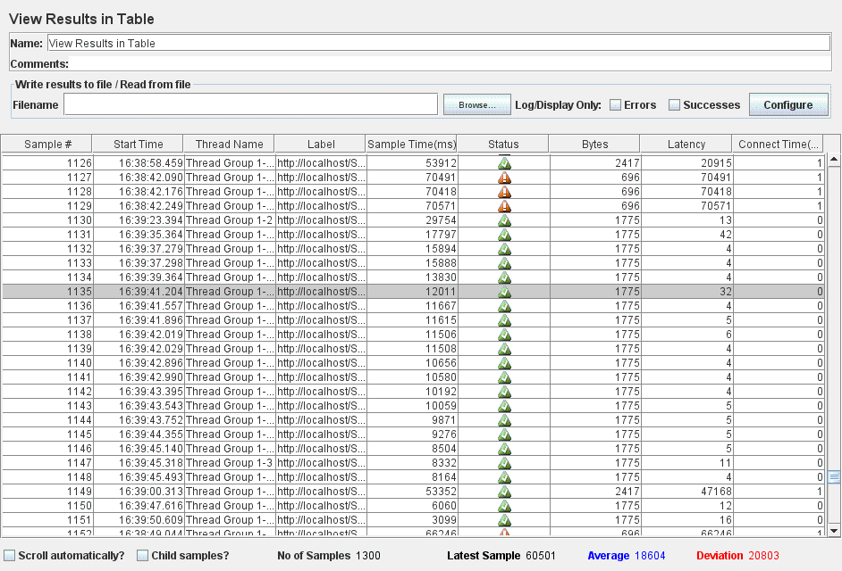

Figure 108: View Results in Table

* The ScrumTaskboard web application is unable to successfully handle all 300 concurrent users (threads) attempting to log in, add a new task (as Scrum Master users), add a tag for that task, visualize the taskboard and then log out. Figure 109 listed below shows several requests for which the application responded with error. Additional information might be gathered by analyzing the results obtained from different measurements:

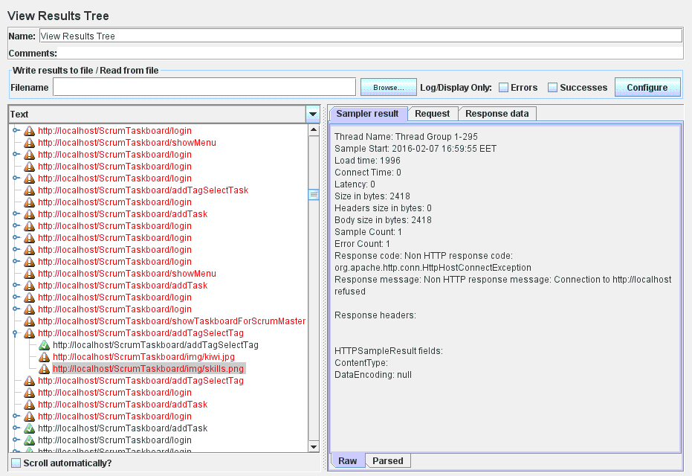

Figure 109: View Results Tree

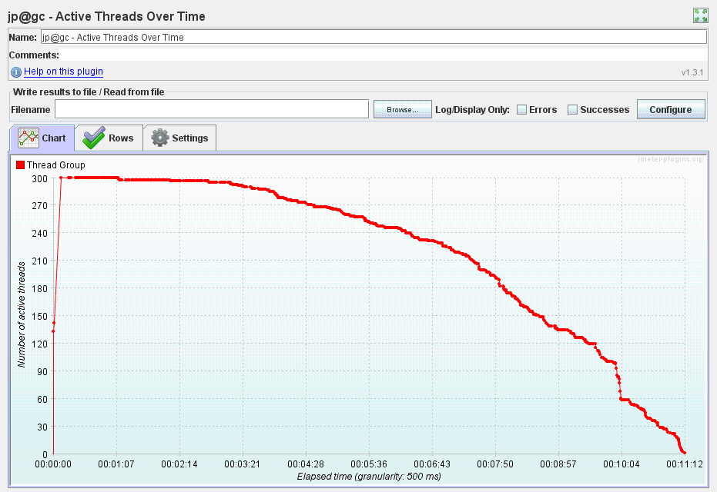

Figure 110: Active Threads Over Time

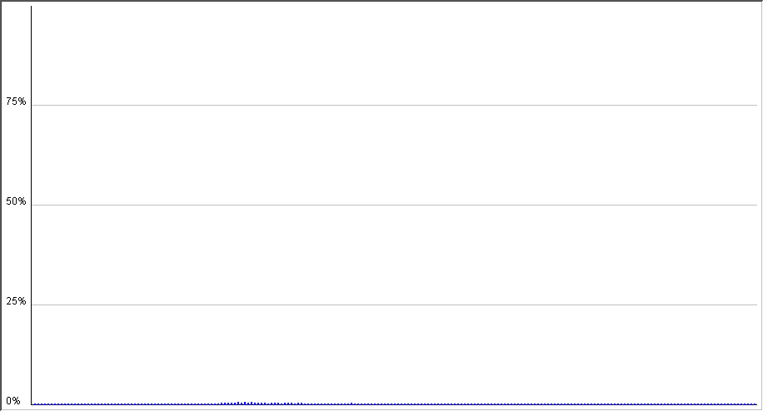

Figure 111: Distribution Graph (alpha)

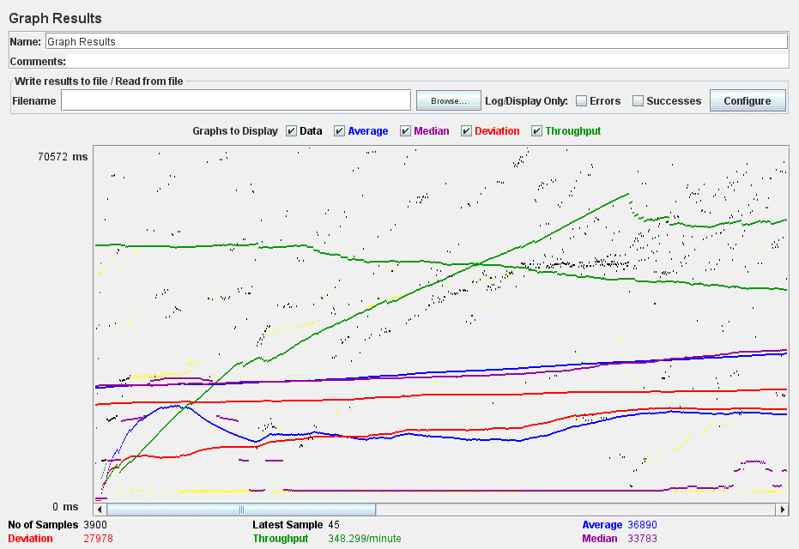

Figure 112: Graph Results

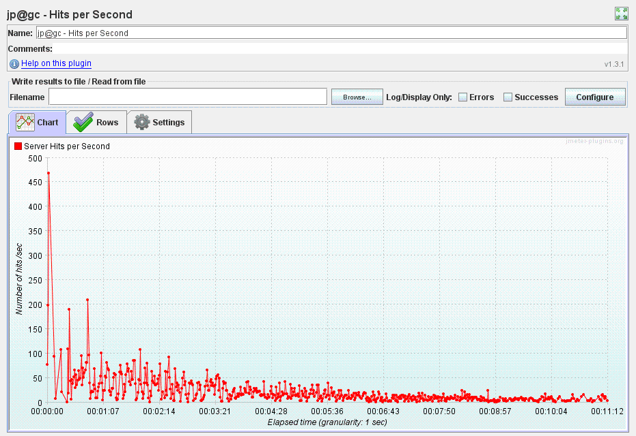

Figure 113: Hits per Second

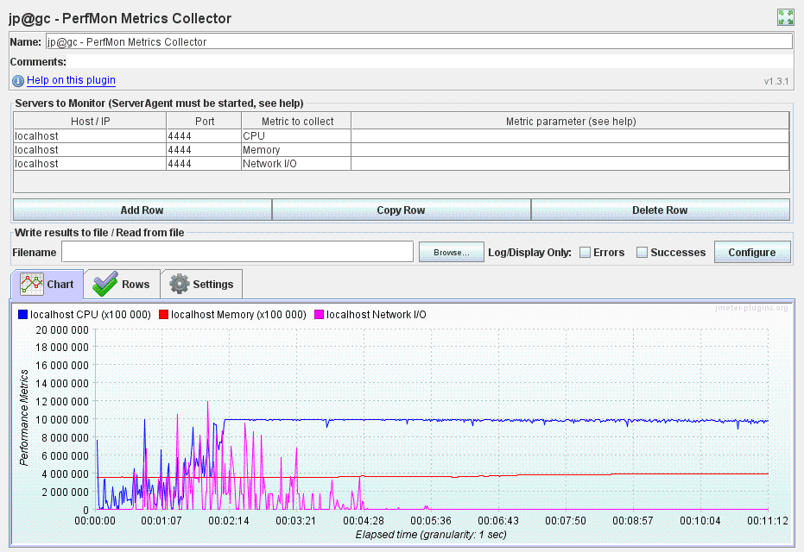

Figure 114: PerfMon Metrics Collector

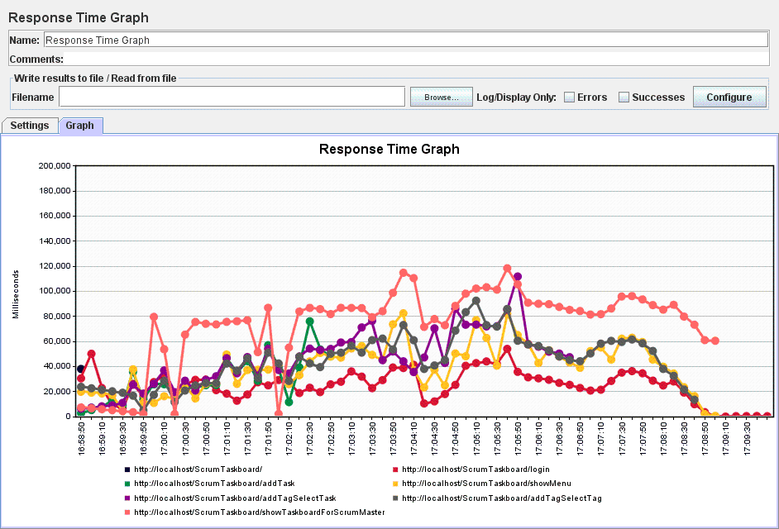

Figure 115: Response Time Graph

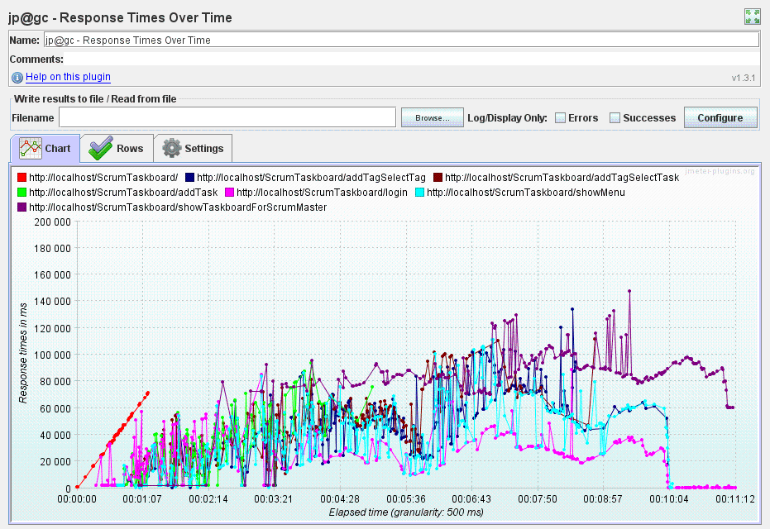

Figure 116: Response Times Over Time

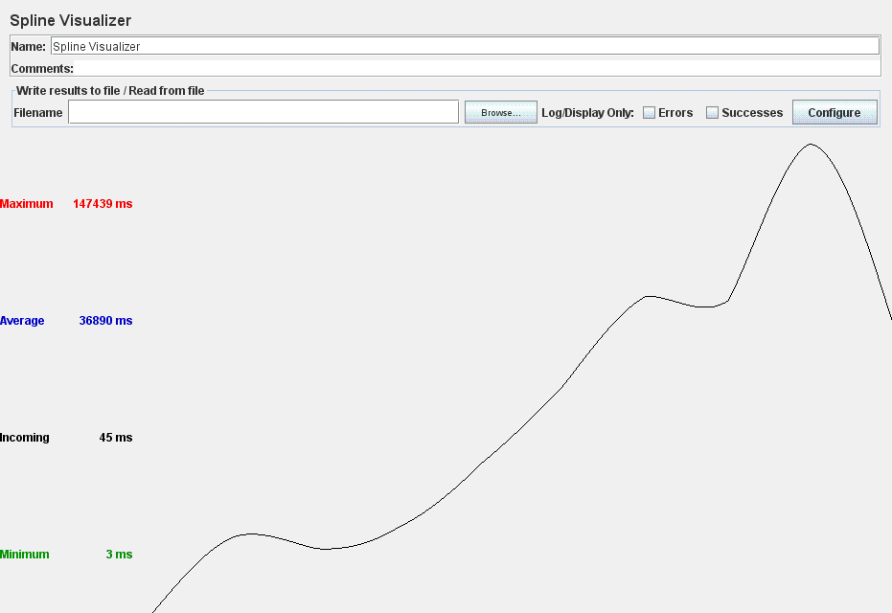

Figure 117: Spline Visualizer

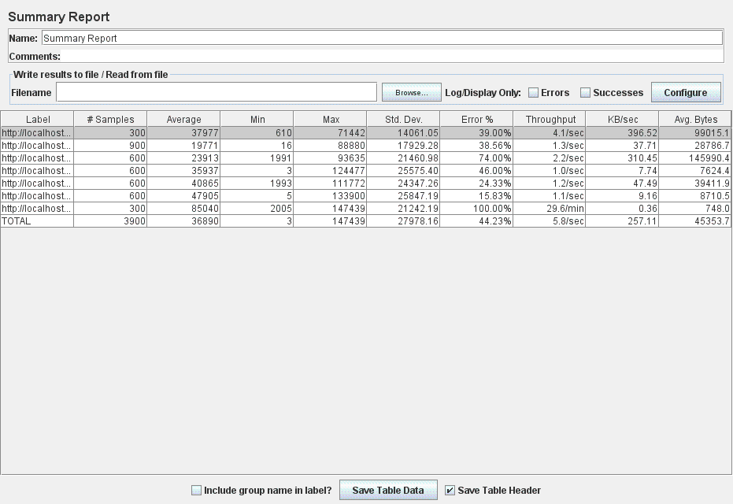

Figure 118: Summary Report

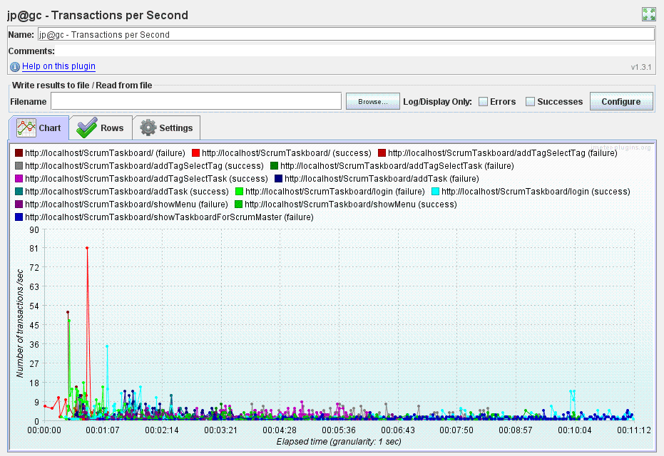

Figure 119: Transactions per Second

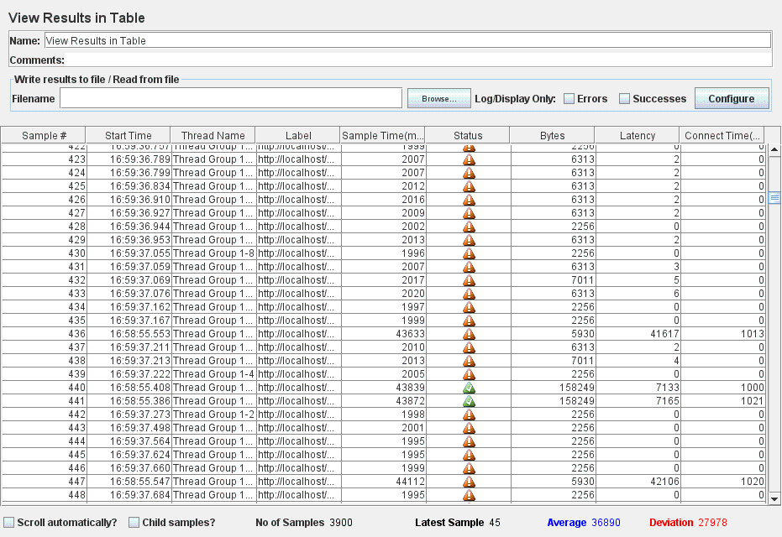

Figure 120: View Results in Table

* For the **Login-Set Sprint Duration-Visualize Burndown Chart Description-Visualize Team Information-Logout** test case:
* For 100 concurrent users (threads) trying to simultaneously log in, set the current sprint duration of the (as Scrum Master users), visualize the burndown chart description as well as relevant team information and then log out, the application responds successfully to all requests. This result is recorded in the images listed below which were obtained from different measurements:

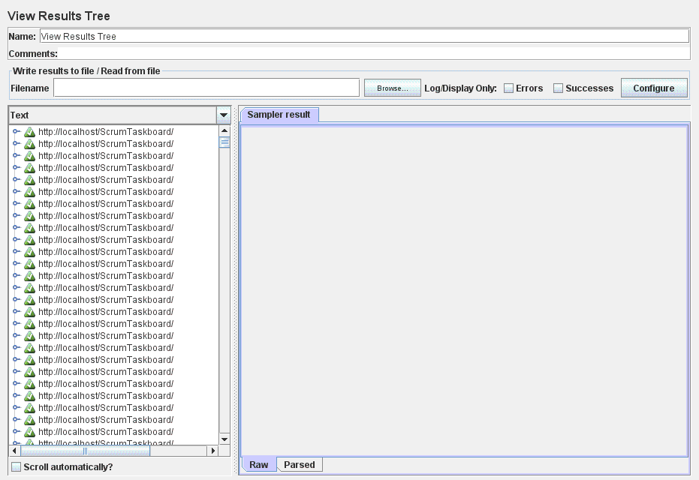

Figure121: View Results Tree

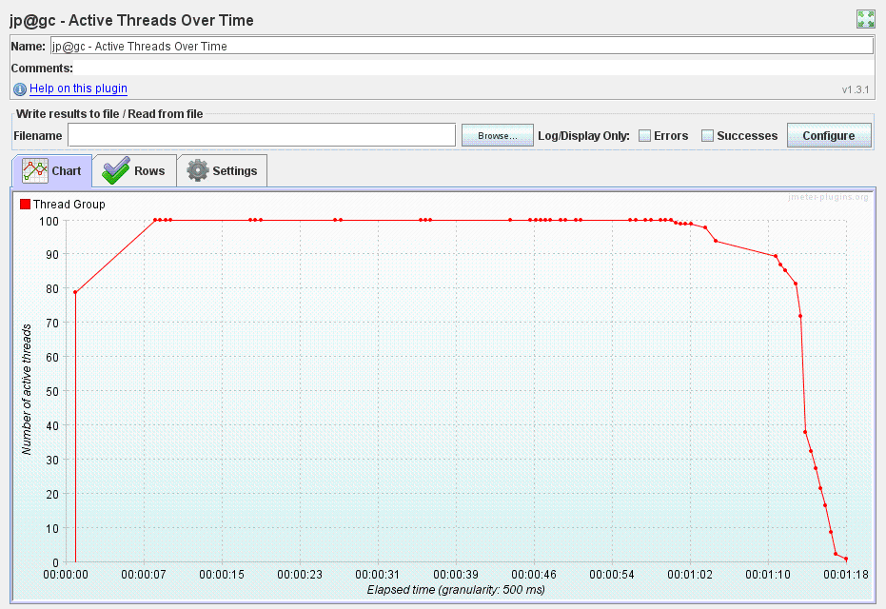

Figure 122: Active Threads Over Time

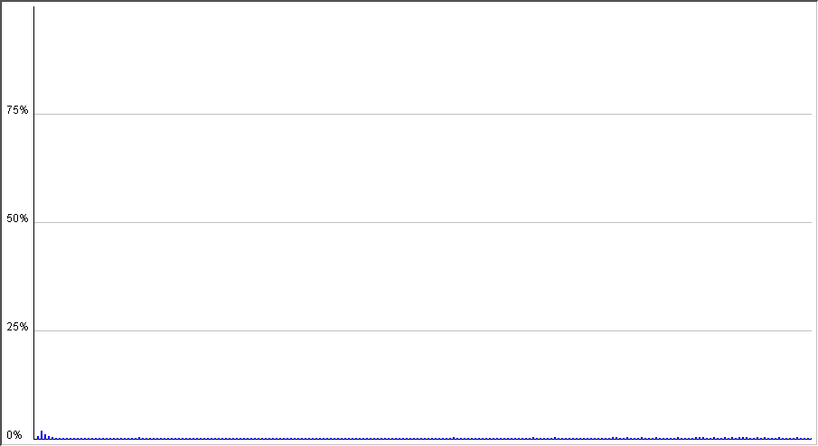

Figure 123: Distribution Graph (alpha)

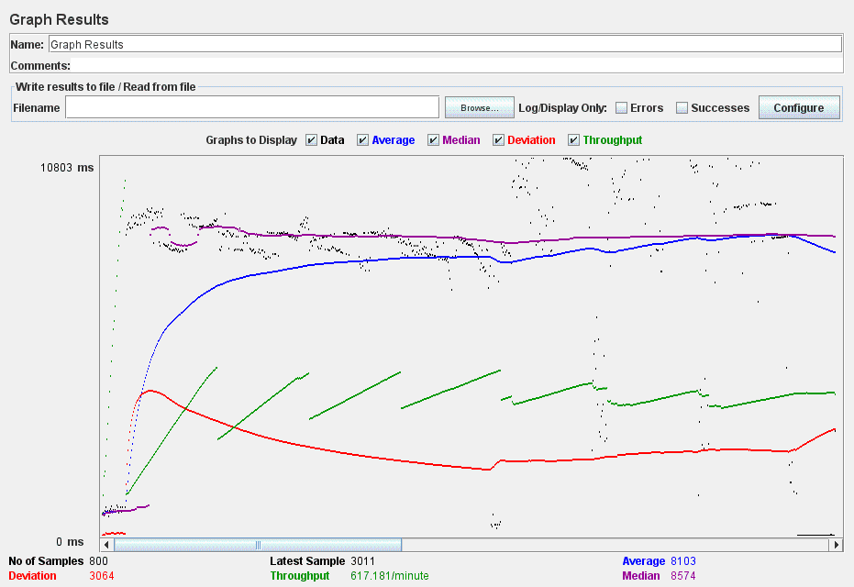

Figure 124: Graph Results

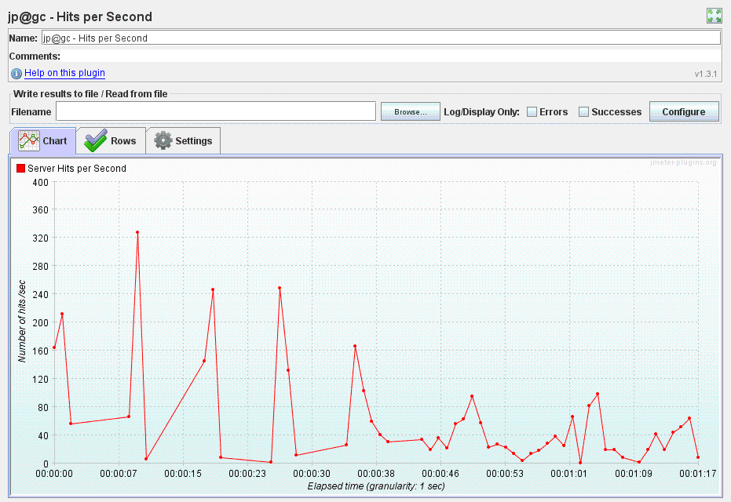

Figure 125: Hits per Second

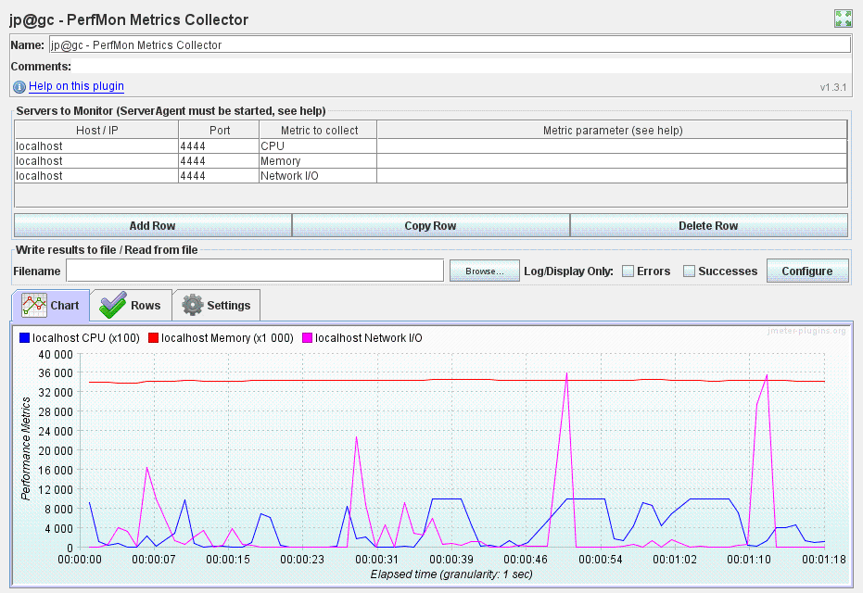

Figure 126: PerfMon Metrics Collector

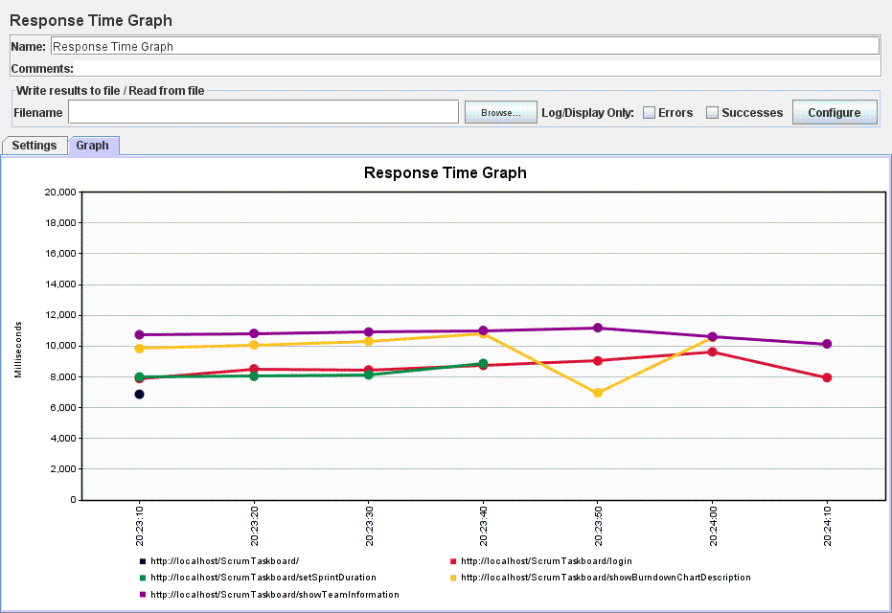

Figure 127: Response Time Graph

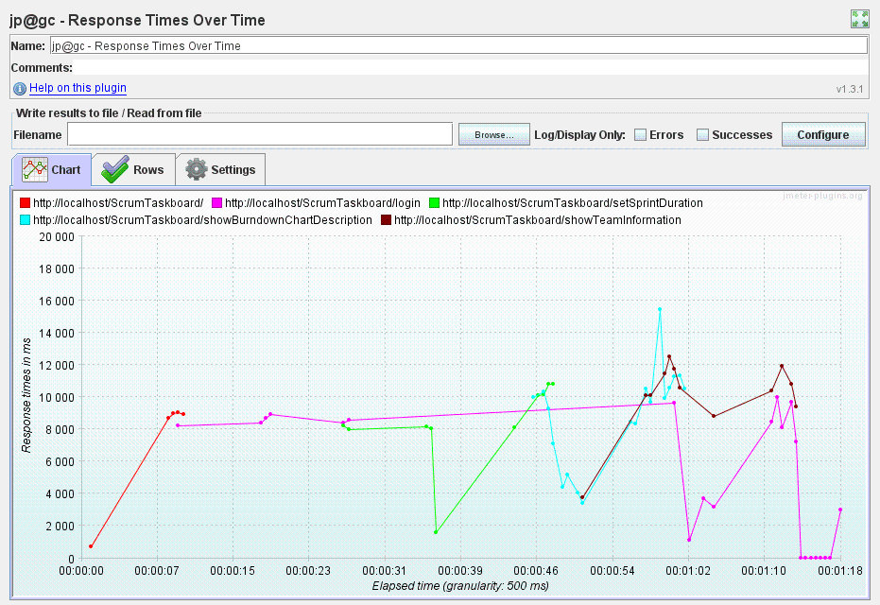

Figure 128: Response Times Over Time

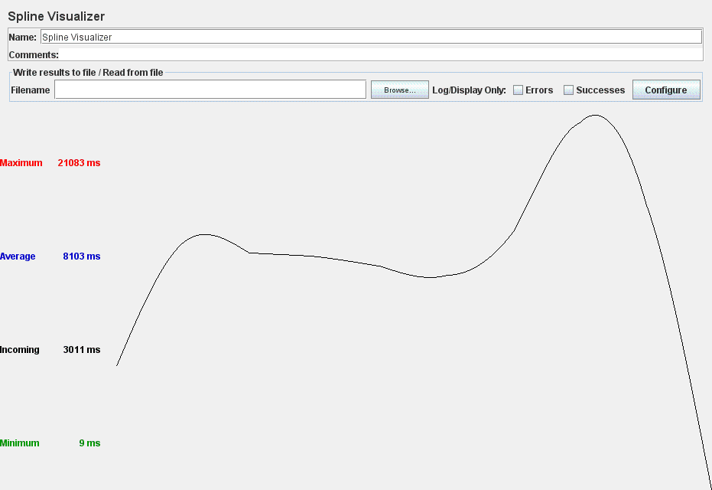

Figure 129: Spline Visualizer

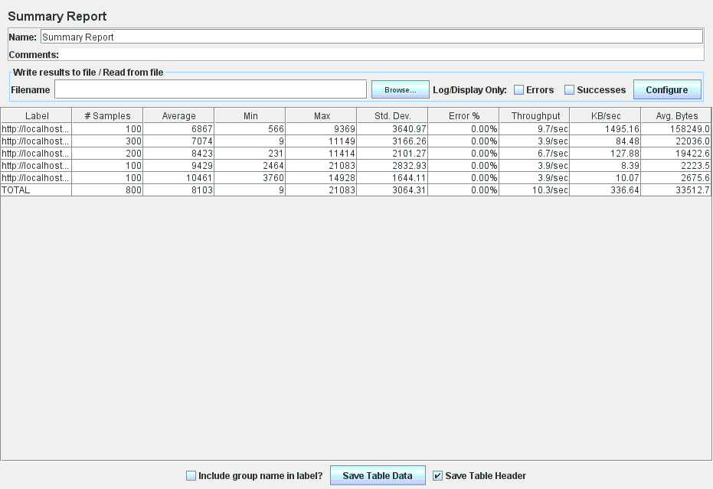

Figure 130: Summary Report

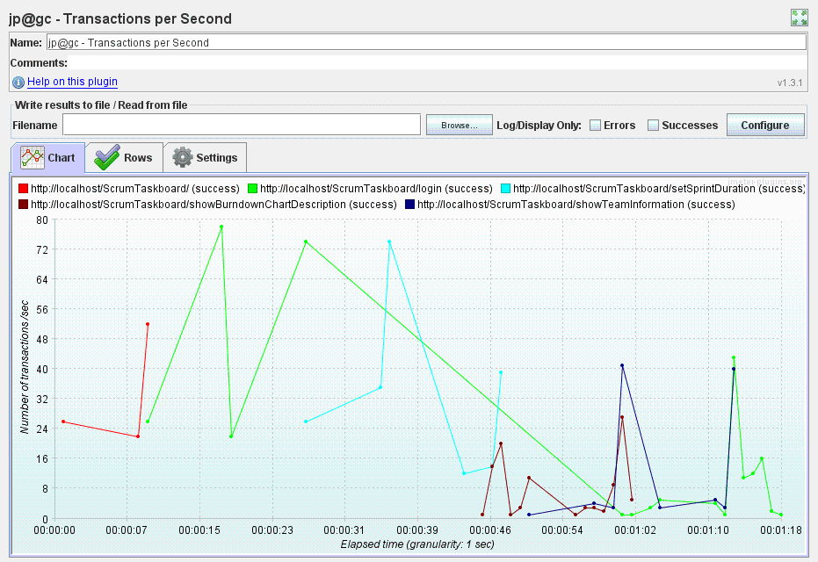

Figure 131: Transactions per Second

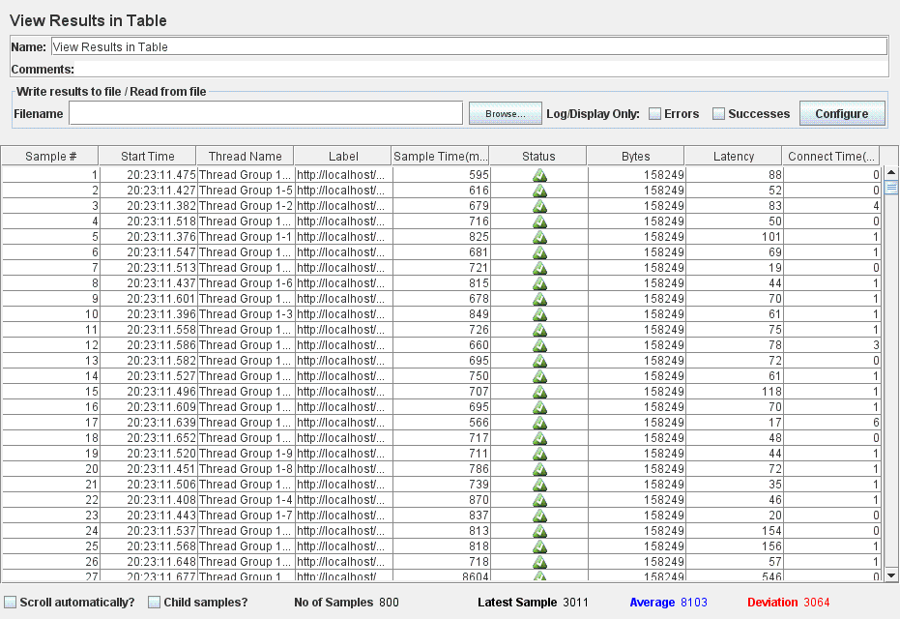

Figure 132: View Results in Table

* The ScrumTaskboard web application is unable to successfully handle all 300 concurrent users (threads) attempting to simultaneously log in, set the current sprint duration (as Scrum Master users), visualize the burndown chart description as well as relevant team information and then log out. Figure 133 listed below shows several requests for which the application responded with error. Additional information might be gathered by analyzing the results obtained from different measurements:

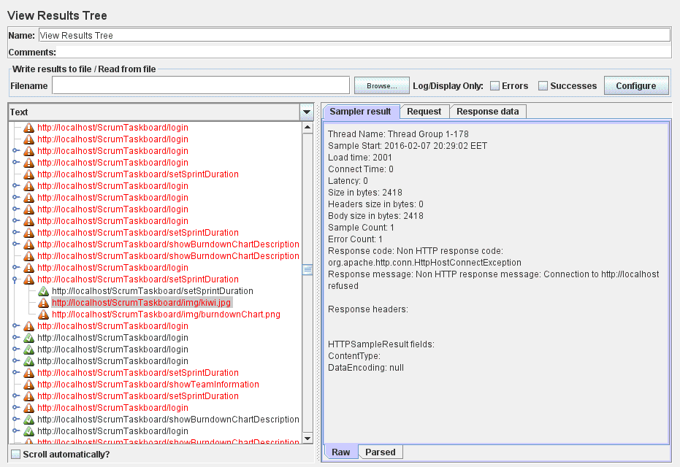

Figure 133: View Results Tree

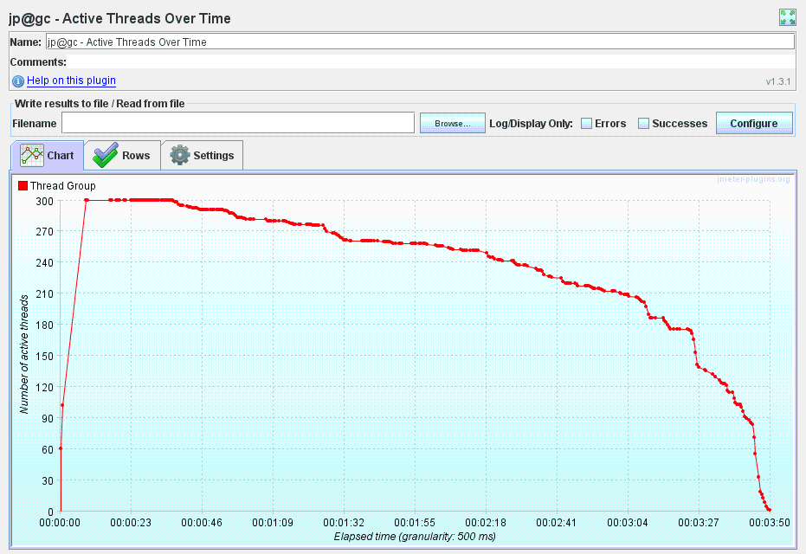

Figure 134: Active Threads Over Time

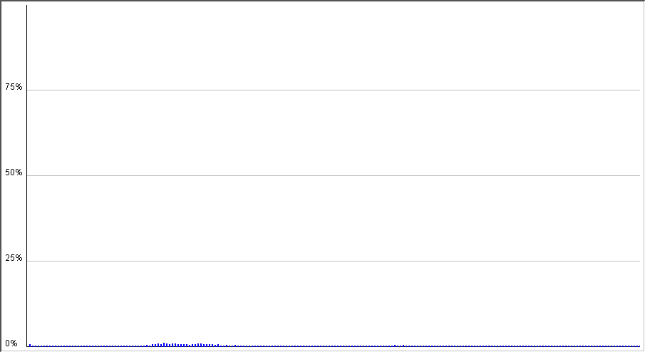

Figure 135: Distribution Graph (alpha)

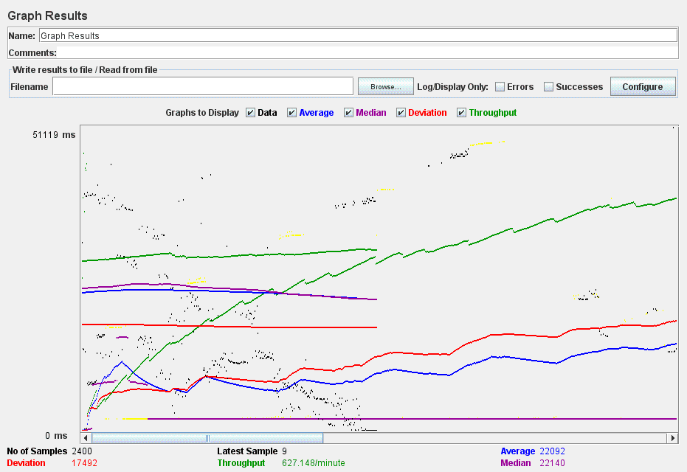

Figure 136: Graph Results

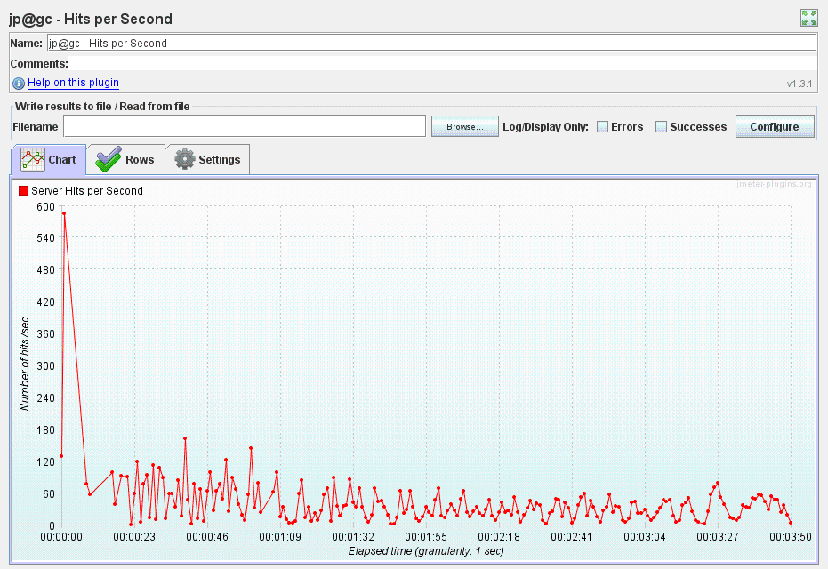

Figure 137: Hits per Second

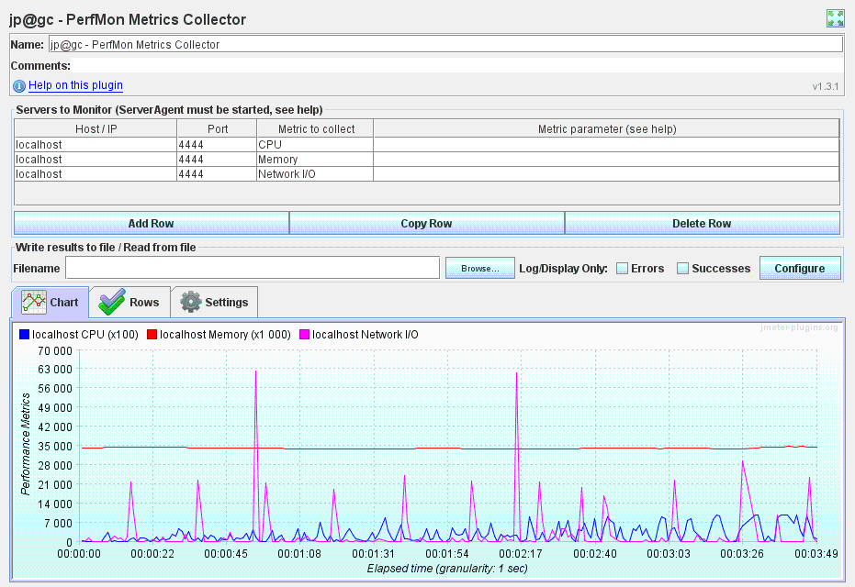

Figure 138: PerfMon Metrics Collector

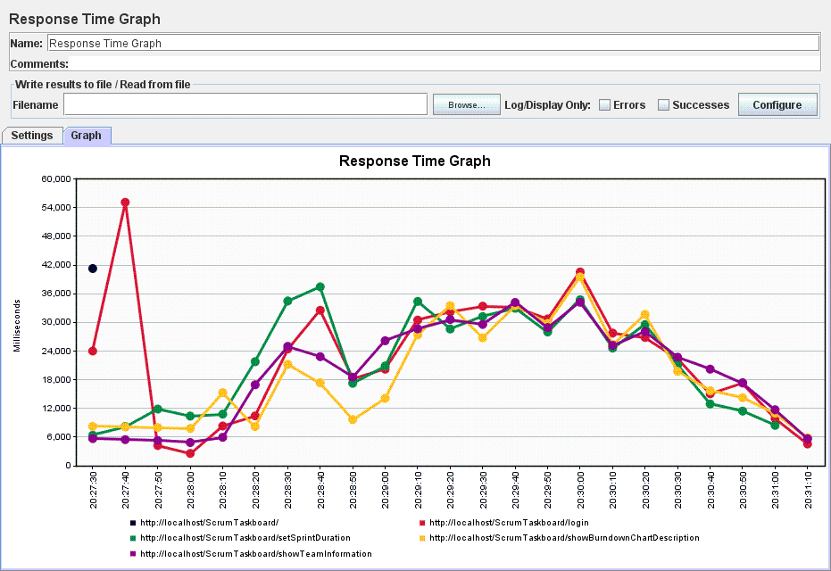

Figure 139: Response Time Graph

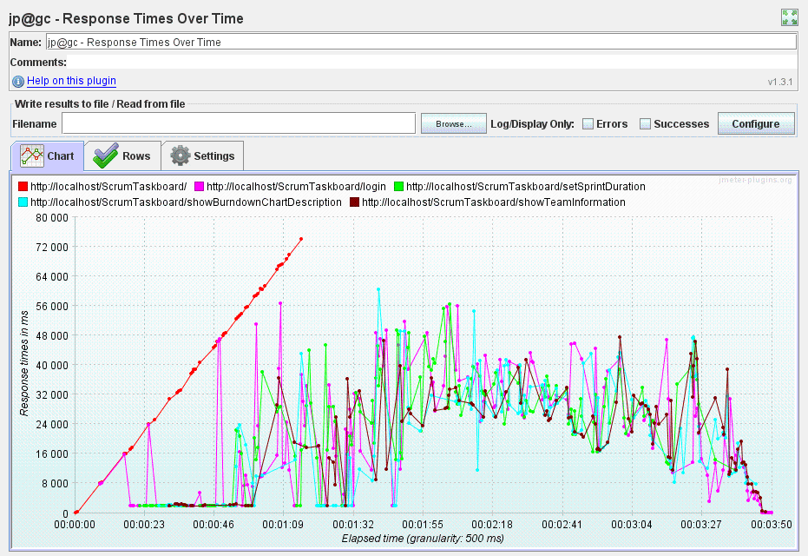

Figure 140: Response Times Over Time

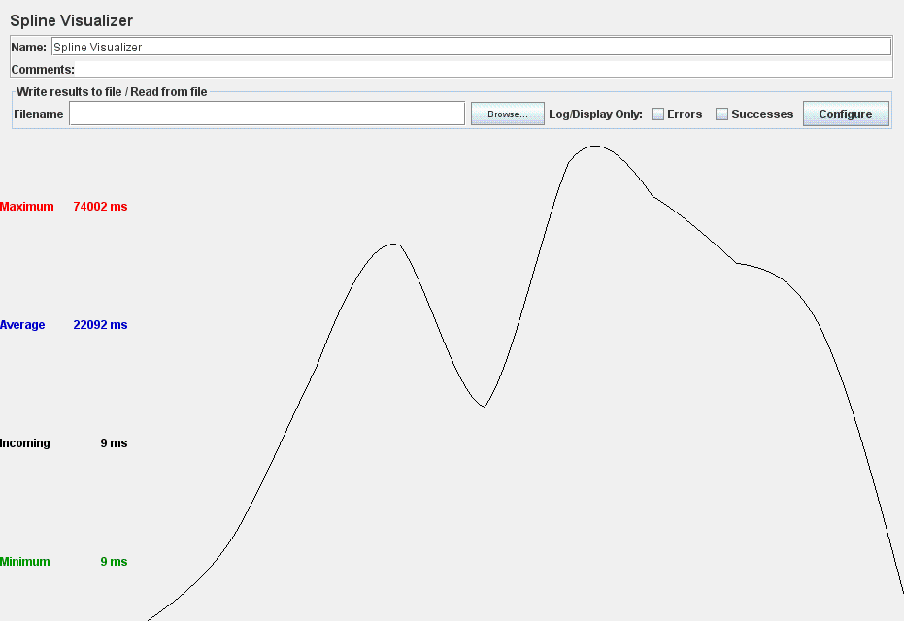

Figure 141: Spline Visualizer

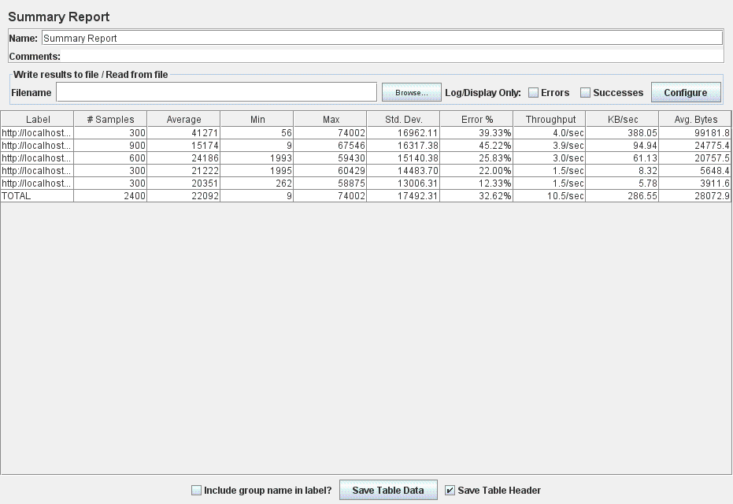

Figure 142: Summary Report

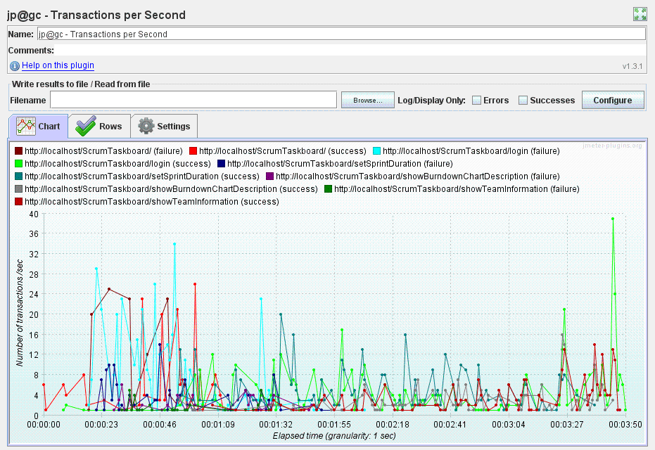

Figure 143: Transactions per Second

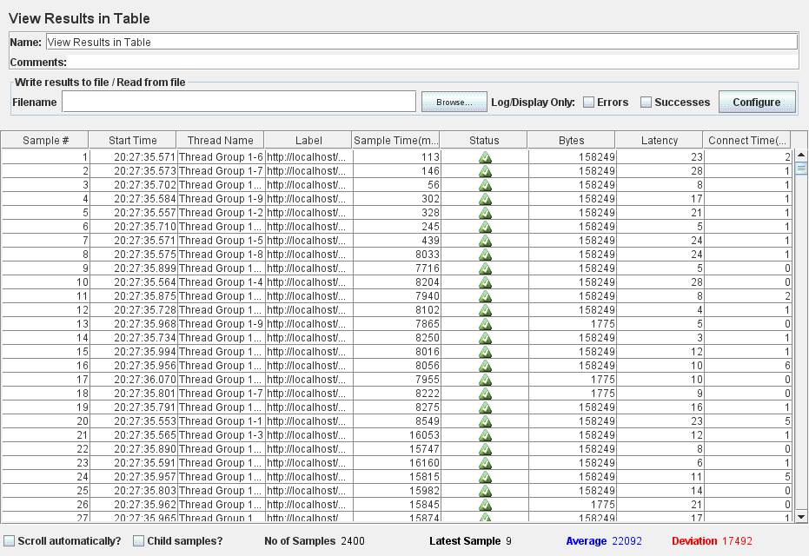

Figure 144: View Results in Table